**NIELIT**

**“ONLINE PIZZA ORDER**

**BOOKING SYSTEM”**

# SUBMITTED BY

**NAME: VIJAY KUMAR SEN**

**REGISTRATION NO: 508897**



**Under the guidance of MR ROHIT VERMA**

**Submitted in partial fulfillment of the requirements for qualifying NIELIT “A”**

**Level**

**PERFORMA OF COVERING LETTER TO THE PROJECT REPORT**

Controller of Examinations,

NIELIT,

Plot No.3, PSP Pocket

Dwarka, Sector-8

New Delhi- 110077

**Sir,**

**I am submitting my “ONLINE PIZZA ORDER BOOKING SYSTEM” “A” Level Project for evaluation. Details of my Registration and postal address, etc is as under:**

**Regn. No:** 508897 **Level : “A”**

**Name: VIJAY KUMAR SEN**

**Father’s Name:** RAJ KUMAR SEN

**Address:**

1. **Residential Address:**

**Vijay Kumar Sen s/o Raj Kumar Sen,**

**Ghosiwada,**

**Merta City, Distt Nagaur, Rajasthan**

**Pin : 341510**

**Mobile No: +91 9665992807**

**(b) Office Address:** ___________________________________

___________________________________

___________________________________

___________________________________

**E-mail Address (Please in block letters only):** MRVIJAYSEN@GMAIL.COM

**“ONLINE PIZZA ORDER**

**BOOKING SYSTEM”**

**A Level PROJECT CERTIFICATE**

**[For Direct as well as candidate from Accredited Institute]**

**This is to certify that the Project / Dissertation entitled, “ONLINE PIZZA ORDER BOOKING SYSTEM” is a bonafide work done by** **VIJAY KUMAR SEN (NIELIT Registration No: 508897 in partial fulfillment of A Level examination and has been carried out under my direct supervision and guidance. This report or a similar report on the topic has not been submitted for any other examination and does not form a part of any other course undergone by the candidate.**

_______________________

## Signature of Guide / Supervisor

**Name** : _________________________

**Place**: _______________

**Designation**: _______________________

**Date**: ________________ **Address** : ________________________

________________________

________________________

________________________

________________________

**TABLE OF CONTENTS**

|  |  |  |
| --- | --- | --- |
|  | Objective & scope of the Project | 5 |
|  | Theoretical background | 8 |
|  | Definition of problem | 9 |
|  | System analysis & design vis-a-vis user requirements | 10 |
|  | System planning (PERT Chart) | 19 |
|  | Methodology adopted, system implementation & details of hardware & software used | 22 |
|  | System maintenance & evaluation | 28 |
|  | Cost and benefit analysis | 32 |
|  | Detailed life cycle of the Project | 33 |
|  | ERD, DFD | 37 |
|  | Input and output screen design | 44 |
|  | Process involved | 97 |
|  | Methodology used for testing : | 121 |
|  | Test Report, printout of the reports, printout of the code sheet | 125 |
|  | User/ operational manual – including security aspects, access rights, back up, controls etc. | 133 |

**1. OBJECTIVE & SCOPE OF THE PROJECT.**

**OBJECTIVE OF THE PROJECT**

Online Pizza Order Booking System’s objectives include:

**1. Faster way to try pizza**- It’s a common thing that new customers will visit the website for directions, a phone number to check the menu or for other information. When they show up on the site and see the “Order Online Now” button.

**2.  Share the news-**When you have people ordering pizza online from the website, simply print something like this “Order online at YourPizzeria.com” on your window signs, takeout menus, yellow page ads, delivery vehicles, newspaper inserts, flyers, coupons, and anywhere else can print your pizzeria’s name. This will help get the word out that it is fast and easy for your customers to place their order.

**3. Free email marketing**-Customers who order online automatically give their email address when they register. This will allow to stay in touch with them using email marketing. This is a power free way to market products and services. One of the good things is that it allows to send coupons and other valuable information to the clients, and this can be a great way to turn a causal pizza eater to a frequent one. The convenience of ordering online can give you an edge over competitors.

**4. Online orders can often be bigger**-This is true for several reasons. One of them is that because customers are never pressured by an agitated or rushed employee, they can take their time to browse your menu. The outcome can be larger tickets. Couple this with offering special offers or discounts for online orders and having a way to cross-promote products, and can really start to see an increase in your sales.

**5. Cost-cutting method**-Allowing order to be placed online can cut costs by reducing the need to take calls. Each online order is one less call for employees to answer and this can add to your bottom line. It might even allow you to operate with fewer employees. This also lets the staff spend more of their time preparing pizza or serving customers, rather than answering phone calls.

**6. Know Delivery Time**- This system will show the time by which the order will be delivered to the customer. For pick-ups customers can fix the time by which they will pick their order.

**7. Reduce Paper Work**- As most of the things will be performed online, it will reduce the usage of paper for the pizzeria.

**8. Improves Efficiency**- This system will make things easier for staff as whole ordering process is done by customer only.

These were the objectives of the online pizza ordering System. Let us now get into the details of the working of this ordering system.

These are just some of the benefits of ordering pizza online

**TECHNICAL OBJECTIVES**

**Sales** [Product sales, and delivery charges]

**Purchase** [Purchase of raw material]

**UOM** [Unit of measurement of goods]

**Vouchers** [Sale, Purchase, Payment, Receipt, Voucher]

**Inventory** [Inventory management system]

**Payroll** [Employee management system, regarding to their salary, overtime, attendance, and other data maintenance]

**Search Bill** [Searching process within bill (payment and receipt bill)]

**Easy to use** [Friendliness environment]

**Secure and server database** [SQL database using as server database PHP front end and Oracle as Backend]

**Delivery** [Stored all information related to about delivery]

**SCOPE**

The scope of the system is defined on the basis of various functionalities provided by the system. The scope can be explained as:-

* Build a web based system.
* Information handling of all users who travel between the difference routes i.e. new passenger list will be created, data retrieval, updates in the information.
* Information handling of the booking of tickets of user’s i.e. new records can be created, data retrieval, update and cancellation of the ticket functionality.
* The scope of the project is to develop customize software package for travel agencies for reducing the manual problems.
* It should deals with the online ticket reservation as well as cancellation.
* The Administrator will take decisions on the basis of valuable reports which is generated by the automation system for the maintenance of the vehicle as well as passenger reservation system.
* This system never decreases the manpower but helps the development of available manpower and optimizes the manpower by which company’s standards and capabilities can be scaled to higher dimension.
* It is very difficult to maintain huge number of vehicles manually, but in automation system the administration will directly known what the vehicle condition and required maintenance.
* Simultaneously the above project also keeps track the information of the drivers and the other employee’s record. The Administrator will handle Payroll system of a particular employee based on their performance.

This topic is chosen as the Internet is here to stay, and many businesses have made their first leap to the Internet with a web site, and many are now moving forwards using the Internet, not only as an advertising and promotion platform, but as an active business platform. Ordering pizza online is fast becoming the latest rage in the pizza world, and if anybody wants to market pizzas. In Order Pizaa.com, Administrator manages the pizza categories, pizza details. A customer will have to register his/her account. After registration, customer can order pizza. once administrator has confirmed a pizza order, and then user is able to track his/her order online. Administration will give an order number or order ID. After login his/her account, Customer can track his/her order status which by this order id. Administrator will update order status like Prepared, Dispathced, Delivered.

**2. THEORETICAL BACKGROUND**

This study is conducted for big companies that can deliver and now accepting orders online through their web sites and even smaller pizza storeowners and small franchisers are getting in on this method.  It can allow customers to select virtually anything pizza storeowners offer, from the type of crust and toppings to extras such as drinks, desserts, salads, etc. Pizza shops constantly strives to develop pizzas that suit the tastes of their consumers and hence delighting them. This web project is useful for pizza shops to manage their orders, customers’ information, production data and more.

Currently organization completed their work on a single excel sheet file, which are very complicated to maintain, and very difficult to use, like remember all formulas (financial, lookup, asthmatics, text, etc), so here we are going to purpose a new automated system with very friendliness environment, by using PHP and My Sql technology.

Online Pizza ordering system is a web based application which enables customers to order their pizzas online for home delivery or pick up from the pizzeria. In this project, Users order and administrator process according to pizza order. As the web clients are expanding exponentially, Online OrderPizza.com requesting project for taking requests from clients. This system enhances client's experience as well as facilitates the workload on the staff of pizzerias. OrderPizza.com Ordering System is to record the details various activities of pizza order and records of customers. Customer can track their order and view order history. It will simplify the task and reduce the paper work.

Customers more likely than not requested your pizzas on telephone for home conveyance. The procedure appears to be anything but difficult to utilize however on occasion there is miscommunication. As there is no visual menu appeared amid a telephone call, the representatives need to rehash a great deal of things and again to the clients. It's a period expending process which now and again bothers clients. Additionally it requires a great deal of investment of the pizzeria staff. It would be a great deal more agreeable for the clients to have an online pizza requesting system.

**3. DEFINITION OF PROBLEM**

The Internet is here to stay, and many businesses have made their first leap to the Internet with a web site, and many are now moving forwards using the Internet, not only as an advertising and promotion platform, but as an active business platform. Ordering pizza online is fast becoming the latest rage in the pizza world, and if anybody wants to market pizzas. Big companies that can deliver are now accepting orders online through their web sites and even smaller pizza storeowners and small franchisers are getting in on this method.  It can allow customers to select virtually anything pizza storeowners offer, from the type of crust and toppings to extras such as drinks, desserts, salads, etc. Pizza shops constantly strives to develop pizzas that suit the tastes of their consumers and hence delighting them. This web project is useful for pizza shops to manage their orders, customers information, production data and more.

Currently organization completed their work on a single excel sheet file, which are very complicated to maintain, and very difficult to use, like remember all formulas (financial, lookup, asthmatics, text, etc), so here we are going to purpose a new automated system with very friendliness environment, by using PHP and My Sql technology

**4. SYSTEM ANALYSIS & DESIGN VIS-Ŕ-VIS USER REQUIREMENTS**

**1. IMPORTANCE OF COMPUTERIZED**

**ONLINE PIZZA ORDER BOOKING SYSTEM**

There are several attributes in which the computer based information works. Broadly the working of computer system is divided into two main groups:

* Transaction System
* Decision Support System

**Transaction System:**

A transaction is a record of some well-defined single and usually small occurrence in a system. Transactions are input into the computer to update the database files. It checks the entering data for its accuracy. This means that numeric data appears in numeric field and character data in character field. Once all the checks are made, transaction is used to update the database. Transaction can be inputted in on-line mode or batch mode. In on-line mode, transactions are entered and updated into the database almost instantaneously. In batch mode, transactions are collected into batches, which may be held for a while and inputted later.

**Decision Support System:**

It assists the user to make analytical decision. It shows the various data in organized way called analysis. This analysis can be made to syrdy preferences and help in making decisions.

Computer system works out best with record maintenance. It will tell you which customer would get how much pending/reports statements. It will also help to search the information about a particular person by simply entering his telephone number. User can store information as per requirement, which can be used for comparison with other reports.

**2 SYSTEM ANALYSIS**

**Principles:**

* 1. Understand the problem before you begin to create the analysis model.
  2. Develop prototypes that enable a user to understand how human machine interaction will occur.
  3. Record the origin of and the reason for every requirement.
  4. Use multiple views of requirements like building data, function and behavioral models.
  5. Work to eliminate ambiguity.

**A Complete Structure:**

The limited time and resources have restricted us to incorporate, in this project, only the main activities that are performed in news sites, but utmost care has been taken to make the system efficient and user friendly.

For the optimum use of practical time it is necessary that every session is planned. Planning of this project will include the following things:

* Topic Understanding.
* Modular Break – Up of the System
* Processor Logic for Each Module.
* Database Requirements.

**Topic Understanding:**

It is vital that the field of application as introduced in the project may be totally a new field. So as soon as the project was allocated to me, I carefully went through the project to identify the requirements of the project.

**Modular Break –Up of the System:**

* Identify The Various Modules In The System.
* List Them In The Right Hierarchy.
* Identify Their Priority Of Development
* Description Of The Modules:

A system analysis is a separation of a substance into parts for study and their implementation and detailed examination.

Before designing any system it is important that the nature of the business and the way it currently operates are clearly understood. The detailed examination provides the specific data required during designing in order to ensure that all the client's requirements are fulfilled. The investigation or the study conducted during the analysis phase is largely based on the feasibility study. Rather it would not be wrong to say that the analysis and feasibility phases overlap. High-level analysis begins during the feasibility study. Though analysis is represented as one phase of the system development life cycle (SDLC), this is not true. Analysis begins with system initialization and continues until its maintenance. Even after successful implementation of the system, analysis may play its role for periodic maintenance and up gradation of the system.

One of the main causes of project failures is inadequate understanding, and one of the main causes of inadequate understanding of the requirements is the poor planning of system analysis.

Analysis requires us to recall the objectives of the project and consider following three questions:

**•** What type of information is required?

• What are the constraints on the investigation?

• What are the potential problems that may make the task

more difficult?

Keeping the above questions in mind and considering the survey conducted to determine the need of the system; the total system was designed and can be described as under:

**Major parts of the system are:**

**Providing Information:**

The system is effectively used to provide large variety of information to the interested customer. The major purpose of the project is to easily provide order details, stock, sales with quick update to latest modifications in the records. This thing is not at all possible in printed material, which are updated only once a few weeks. It also gives information about the general usage of the system for first time visitors. The system itself works as a information provider for Company.

**Alert when available:**  Through the survey it was clearly that there is a need to device an alternative way for providing alert facility to the user. Sometimes the product which customer demand is not available at that moment, user can register demand of customer and when its available, system gives an alert to the user that customer had registered a customer request with the same match.

**Constraints:** After the objectives were clear during the analysis phase, it was essential to understand the constraints in order to plan and avoid problems arising during detailed analysis.

**Technology** *-* the customer may be committed to a particular hardware or software solution. The software required in this case is: compete Java developer kit, Microsoft windows environment for MS Sql server.

**Budget** -if budget is a real constraint, the budget of the new system proposed would be constantly compared with that of the existing system or any Alternativessolution. In this case during the economic feasibility study it has been clearly proved that the new system is definitely more feasible than the alternative solution possible. Organization must implement a system which saves the effort, also its provide an easy method for customer who investigate each detail itself.

**Scope *-*** what is the area under investigation in this project? What are the boundaries of the system? What is the extent of possible usage of the new system?

More and more people are now having access to organization and watch independently Details of new upcoming stock. Hence the scope is constantly increasing. However its usage can be increased many folds with a little investment from the organization side by implanting touch screen computer kiosks at various convenient positions at the service station.

**Environmental Analysis:­**

The external entities for an organization are its Supplier's customers or any individual.

Else then that we also have to look that it should not be harmful to our environment in the form of polluting or degrading our resources in any manner.

**3 METHODS USED FOR GATHERING INFORMATION**

The methods used for gathering information about the existing information system are as followed.

**(a) Review of records.**

(b) Observation of the functioning system.

(c) Interviews.

(d) Questionnaires.

In order to create an informative and practical system, a system analyst would have to have some kind of way to view the current system. Receiving feed back on what can be done to improve the current system, and how much the current system is acceptable to the users.

**1) Requirement analysis: -**

The main part of problem is to obtain a clear understanding of the needs of user and

what exactly are desired from the software. It is used for specifying the

requirement.

**Fact finding tools:**

After obtaining the background knowledge, I began to collect data on the existing

system's output, input, and costs. The tools used in data collection / information

gathering are:

Review of the written Documents

On-site Observation

Interviews

Questionnaires

**Review of documents**

**On-site observation**

**Interview**

**Questionnaires**

**Information gathering tools**

**Data organization**

**Review of the written documents:**

In this phase we analyzed all the documents like the day books, supply report, order generating forms, supply forms, account etc. All these things describe the format and functions of the current system included in most manuals are system requirement that help determine how III various objectives are met.

The form is one of the most important source through which ! draw some conclusion like:

1. Who use the form(s)? How important are they to the user?

2. Do the forms include all the necessary information? What item should be added or deleted?

3. How readable and easy to follow is the form?

4. How does the information in the form help other user make better decision?

5. What other uses does the form offer the user area? By analyzing all the details we draw a conclusion that what are the merit and De-merit of the current phase. Will the company contain all the back up of all the important document of not sales person contains all the information about the available vehicles or not. But above all there are some problems with the on site observations that one analyst must face during analysis like:

1. Take long time and get inefficient result

2. Attitude and motivation of subject cannot be readily observed

3. Observation are subject to error

4. In a complex situation it can be very time­ consuming. So for this we switched towards the other fact finding tools like interviews and questionnaires.

**4 INTERVIEWS AND QUESTIONNAIRES:**

The interviews is a face to face interpersonal role situation in which a person cal*l*ed The interview asks a person being interview questions designed to gather information about a problem area. The interview is the oldest and most often used device for gathering information in systems work. It has qualities that behavioral and on-site observations do not possess .it can be used for two main purposes:

(a) as an exploratory device to identify relations or verify Information

(b) to capture information as it exists

**1. on site observation:**

It is not the easy task to do. In the on site observation the main objective is to get close as possible to the real system that are being studied. There are some questions that can serve as a guide for the onsite observations:

1.What kind of the system is it? What does it do?

2. Who runs the system? Who are the important people in it?

3. What is the history of the system? How it get to its present stage of the Development first in this phase we more likely listened than talk and to and to listen with a sympathetic

and genuine interest when information is conveyed. We have not to give any advice or passing moral judgment on what is observed. Not to argue with anyone or not to show any hostility towards one person and undue friendliness towards another.So in the on site observation we first visited to the entire organization watched all the transactions, watched the way of taking orders by the sales executive. What types of forms are used in the entire place? Are all forms are written, printed or not.

**There are four primary advantages of the interviews:**

1. Its flexibility

2. Easy to validate the information gathered

3. Effective technique for elicit information about complex subject

4. Instance, goals must be based on what competitors do.

**Questionnaires:**

It is usually associated with the self-administrated tools with items of the closed or fixed alternative type. By this nature a questionnaires offer the following advantages:

(a) It is economical and requires less skill to administer than the interview

(b) Unlike the interview which generally questions one subject at time questionnaire can be administrated to large number of individuals simultaneously.

(c) The questionnaires place less pressure on the subjects for immediate responses. Respondents have to think the question over and do calculations to provide more accurate data.

**Mainly interviews and questionnaires are divided into two categories.**

1. The unstructured alternative

2. The structured alternative

The unstructured interview is a relatively nondirective information technique. The role of the analyst as an interviewer is to encourage the respondent to talk freely and serve as a catalyst to the expression of feeling and opinions.

In the structured alternative approach the question are presented with exactly the same wording and in the same order to all subjects. Questions may be closed or open ended. An open-ended question requires no response direction or the specific response.

An analyst asks the questions at each level of management either it is top level, middle level or bottom level and at each department in the client's site and at the manufacturer.

**5. SYSTEM PLANNING (PERT CHART)**

**Gant Chart**

A **Gantt chart** is a graphical representation of the duration of tasks against the progression of time. A Gantt chart is a useful tool for planning and scheduling projects

A Gantt chart is a type of [bar chart](http://en.wikipedia.org/wiki/Bar_chart) that illustrates a [project schedule](http://en.wikipedia.org/wiki/Schedule_%28project_management%29). Gantt charts illustrate the start and finish dates of the [terminal elements](http://en.wikipedia.org/wiki/Terminal_element) and summary elements of a [project](http://en.wikipedia.org/wiki/Project). Terminal elements and summary elements comprise the [work breakdown structure](http://en.wikipedia.org/wiki/Work_breakdown_structure) of the project. Some Gantt charts also show the [dependency](http://en.wikipedia.org/wiki/Dependency_%28project_management%29).

Gantt chart is a project scheduling technique. Progress can be represented easily in a Gantt chart, by coloring each milestone when completed. The project will start in the month of August end after 4 months at the end of September .

**November**

**October**

**September**

**August**

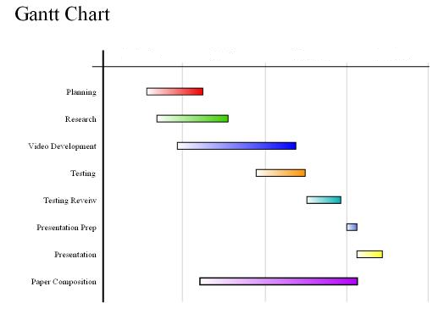

**Video Development**

**Research**

**Planning**

**Testing Review**

**Testing**

**Presentation**

**Presentation Prep**

**Paper Composition**

**Pert Chart**

**PERT** (Project Evaluation and Review Technique) charts consist of a network of boxes and arrows. The boxes represent activities and the arrows represent task dependencies.

PERT is a method to analyze the involved tasks in completing a given project, especially the time needed to complete each task, and identifying the minimum time needed to complete the total project.

A PERT chart is a project management tool used to schedule, organize, and coordinate tasks within a project. PERT stands for Program Evaluation *Review Technique*, a methodology developed by the U.S. Navy in the 1950s to manage the Polaris submarine missile program. A similar methodology, the *Critical Path Method* (CPM) was developed for project management in the private sector at about the same time. A critical path in a PERT chart is shown by using thicker arrows.

**Steps in the PERT Planning Process**

PERT planning involves the following steps:

1. Identify the specific activities and milestones.
2. Determine the proper sequence of the activities.
3. Construct a network diagram.
4. Estimate the time required for each activity.
5. Determine the *critical path*.
6. Update the PERT chart as the project progresses.

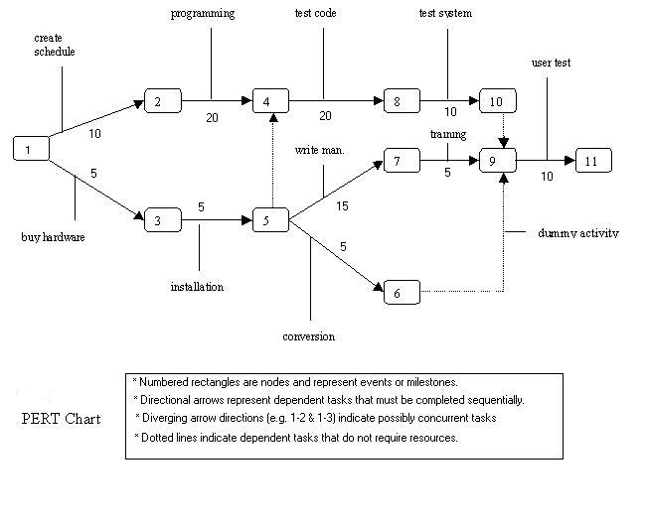

**FIGURE B: PERT Chart** representation of the **“ONLINE PIZZA ORDER BOOKING SYSTEM ”**

PERT charts are a more sophisticated form of activity chart. In activity diagrams only the estimated task durations are represented. Since the actual durations might vary from the estimated durations, the utility of the activity diagrams is limited.

**6. METHODOLOGY ADOPTED, SYSTEM IMPLEMENTATION & DETAILS OF HARDWARE & SOFTWARE USED**

**SOFTWARE & HARDWARE REQUIREMENTS**

The need of today’s software development is competence in a GUI based front-end tool, which can connect to Relational Database engines. This gives the programmer the opportunity to develop client server based commercial applications.

**HARDWARE:**

Processor : Pentium 2.4 GHz or above

Memory : 2 GB RAM or above

Cache Memory : 128 KB or above

Printer : Laser Printer

Pen Drive : 5 GB

**SOFTWARE:**

Operating System : Windows 8

Font-End Too l : PHP, Java Script

Back-End : My SQL (phpmyadmin)

**PHP**

PHP is a widely-used general-purpose scripting language that is especially suited for Web development and can be embedded into HTML. PHP, or PHP: Hypertext Preprocessor, is a widely used, general-purpose scripting language that was originally designed for web development, to produce dynamic web pages. It can be embedded into HTML and generally runs on a web server, which needs to be configured to process PHP code and create web page content from it. It can be deployed on most web servers and on almost every operating system and platform free of charge. PHP is installed on over 20 million websites and 1 million web servers. PHP has evolved to include a command line interface capability and can also be used in standalone graphical applications.

**INTRODUCTION TO PHP**

**“Client-Server approach with XML / PHP, MY SQL”**

The need of today’s software development is competence in a GUI based front-end tool, which can connect to Relational Database engines. This gives the programmer the opportunity to develop client server based commercial applications.

**FRONT END**

PHP, MY SQL programming tools are complete programming environments. It allows programmers to build a GUI program using the various on-screen controls such as buttons, text, menus, boxes etc. These controls are placed on a form and then the processing details related with each control are filled in.

In the business world, competitive strategies have become the order of the day to improve quality, cut costs and provide a high response customer service base. Most organizations today need to be market driven and do a lot of value addition to their products and services. This naturally calls for rational decision making, which requires information. Information Technology or IT provides that effective channel to support and implement this strategy. Client/Server is the technology that empowers the desktop, thus setting a trend for the way successful organizations will use technology in the next decade.

**INTRODUCTION TO PHP, MY SQL**

**INTRODUCTION OF PHP**

My SQL™ and PHP are two of the most popular open source technologies to emerge during the past decade. PHP is a powerful language for writing server-side Web applications. MySQL is the world's most popular open source database. Together, these two technologies provide you with a powerful platform for building database-driven Web applications.

This hands-on My SQL and PHP training course teaches attendees everything they need to successfully build data-driven Web sites using My SQL and PHP.

My SQL

INTRODUCTION

It's very likely that the first task the administrator will want to undertake is proper configuration of MySQL's configuration file. This file, entitled my.cnf, stores default startup options for both the server and for clients. Correct configuration of this file can go a long way towards optimizing MySQL, as various memory buffer settings and other valuable options can be set here.

Interestingly, the scope of this file can be set according to its location. The settings will be considered global to all My SQL servers if stored in /etc/my.cnf. It will be global to a specific server if located in the directory where the My SQL databases are stored (/usr/local/mysql/data for a binary installation, or /usr/local/var for a source installation). Finally, its scope could be limited to a specific user if located in the home directory of the My SQL user (~/.my.cnf). Keep in mind that even if My SQL does locate a my.cnf file in /etc/my.cnf (global to all My SQL servers on that machine), it will continue its search for a server-specific file, and then a user-specific file. You can think of the final configuration settings as being the result of the /etc/my.cnf, mysql-data-dir/my.cnf, and ~/.my.cnf files.

In order to aid administrator's in the proper configuration of this file, the MySQL developers have included four sample my.cnf files within the distribution. Their names are my-huge.cnf.sh, my-large.cnf.sh, my-medium.cnf.sh, and my-small.cnf.sh, and each denotes recommended configuration settings in accordance with system resource availability.

### DATA TYPE

. **TEXT TYPES**

|  |  |
| --- | --- |
| CHAR( ) | A fixed section from 0 to 255 characters long. |
| VARCHAR( ) | A variable section from 0 to 255 characters long. |
| TINYTEXT | A string with a maximum length of 255 characters. |
| TEXT | A string with a maximum length of 65535 characters. |
| BLOB | A string with a maximum length of 65535 characters. |
| MEDIUMTEXT | A string with a maximum length of 16777215 characters. |
| MEDIUMBLOB | A string with a maximum length of 16777215 characters. |
| LONGTEXT | A string with a maximum length of 4294967295 characters. |
| LONGBLOB | A string with a maximum length of 4294967295 characters. |

The ( ) brackets allow you to enter a maximum number of characters will be used in the column.

VARCHAR(20)

CHAR and VARCHAR are the most widely used types. CHAR is a fixed length string and is mainly used when the data is not going to vary much in it's length. VARCHAR is a variable length string and is mainly used when the data may vary in length.   
  
CHAR may be faster for the database to process considering the fields stay the same length down the column. VARCHAR may be a bit slower as it calculates each field down the column, but it saves on memory space. Which one to ultimatly use is up to you.   
  
Using both a CHAR and VARCHAR option in the same table, MySQL will automatically change the CHAR into VARCHAR for compatability reasons.   
  
BLOB stands for Binary Large OBject. Both TEXT and BLOB are variable length types that store large amounts of data. They are similar to a larger version of VARCHAR. These types can store a large piece of data information, but they are also processed much slower.   
  
**NUMBER TYPES**

|  |  |
| --- | --- |
| TINYINT( ) | -128 to 127 normal 0 to 255 UNSIGNED. |
| SMALLINT( ) | -32768 to 32767 normal 0 to 65535 UNSIGNED. |
| MEDIUMINT( ) | -8388608 to 8388607 normal 0 to 16777215 UNSIGNED. |
| INT( ) | -2147483648 to 2147483647 normal 0 to 4294967295 UNSIGNED. |
| BIGINT( ) | -9223372036854775808 to 9223372036854775807 normal 0 to 18446744073709551615 UNSIGNED. |
| FLOAT | A small number with a floating decimal point. |
| DOUBLE( , ) | A large number with a floating decimal point. |
| DECIMAL( , ) | A DOUBLE stored as a string , allowing for a fixed decimal point. |

The integer types have an extra option called UNSIGNED. Normally, the integer goes from an negative to positive value. Using an UNSIGNED command will move that range up so it starts at zero instead of a negative number.   
  
**DATE TYPES**

|  |  |
| --- | --- |
| DATE | YYYY-MM-DD. |
| DATETIME | YYYY-MM-DD HH:MM:SS. |
| TIMESTAMP | YYYYMMDDHHMMSS. |
| TIME | HH:MM:SS. |

**MISC TYPES**

|  |  |
| --- | --- |
| ENUM ( ) | Short for ENUMERATION which means that each column may have one of a specified possible values. |
| SET | Similar to ENUM except each column may have more than one of the specified possible values. |

ENUM is short for ENUMERATED list. This column can only store one of the values that are declared in the specified list contained in the ( ) brackets.

ENUM('y','n')

You can list up to 65535 values in an ENUM list. If a value is inserted that is not in the list, a blank value will be inserted.

SET is similar to ENUM except SET may contain up to 64 list items and can store more than one choice

## 

**ENVIRONMENT / OPERATING SYSTEM**

The age of standalone computing is long gone and it is now a world of networks. In this context, it is imperative for users to understand issues involved in working in a multi-user environment. Windows NT today is the most sought after Multi-user Operating System in the world. This is a 32-bit, powerful, user friendly and robust network operating system from Microsoft.

Windows NT is a big step up from Windows 95 both in terms of price and in terms of capabilities. NT Server is a well-built, fully functional, multi-user, multitasking operating system.

The release of NT Server 4 adds the popular Windows 95 user interface, the Internet Information Server (IIS) – capable of running Web, FTP, and Gopher services - a search engine called Index Server, the FrontPage HTML authoring package, and the Internet Explorer, all of which make Windows NT server a tough act to beat as a robust, capable web server.

The suggested Operating System for the server computer is Windows NT Server and for client computer is Windows 95.

**7. SYSTEM MAINTENANCE & EVALUATION**

**POST IMPLEMENTATION MAINTENANCE AND REVIEW**

As we know, creating software is one thing and the implementation of the created software is another. The process of implementing software is much difficult as compared to the task of creating the project. First we have to implement the software on a small scale for removing the bugs and other errors in the project and after removing them we can implement the software on a large scale.

Before we think in terms of implementing the Software on a large basis, we must consider the Hardware requirements.

Whenever we develop software or project a certain hardware and software is being used by the programmer for developing the project. The hardware and software to be used by the programmer for developing the project should be such that it would result in the development of a project, which would satisfy all the basic needs for which the project has been created by the programmer. The Hardware should be such that cost constraints of the Client should also be taken into account without affecting the performance.

**HARDWARE EVALUATION FACTORS**

When we evaluate computer hardware, we should first investigate specific *physical and performance* characteristics for each hardware component to be acquired. These specific questions must be answered concerning many important factors. These *hardware evaluation* *factors* questions are summarized in the below figure.

Notice that there is much more to evaluating hardware than determining the fastest and cheapest computing device. For e.g. the question of possible obsolescence must be addressed by making a technology evaluation. The factor of *ergonomics* is also very important. Ergonomics is the science and technology that tries to ensure that computers and other technologies are "user-friendly", that is safe, comfortable and easy to use. *Connectivity is* another important evaluation factor, since so many computer systems are now interconnected within wide area or local area telecommunications networks.

**HARDWARE EVALUATION FACTORS**

1) Performance

2) Cost

3) Reliability

4) Availability

5) Compatibility

6) Modularity

7) Technology

8) Ergonomics

9) Connectivity

10) Environmental requirements

11) Software

12) Support

**SOFTWARE EVALUATION FACTORS**

Software can be evaluated according to many factors similar to the hardware evaluation. Thus the factors of *performance, cost, reliability, compatibility, modularity, technology, ergonomics, and support* should be used to evaluate proposed software acquisitions. In addition, however, *the software evaluation factors* are summarized in below figure. For e.g. some software packages require too much memory capacity and are notoriously slow, hard to use, or poorly documented. They are not a good selection for most end users, even if offered at attractive prices.

**SOFTWARE EVALUATION FACTORS:**

1. **EFFICIENCY:** is the software a well-written system of computer instructions that does not use much memory capacity or CPU time?
2. **FLEXIBILITY:** can it handle its processing assignments easily without major modifications?
3. **SECURITY:** does it provide control procedures for errors, malfunctions and improper use?
4. **LANGUAGE:** do our computer programmers and users write it in a programming language that is used?
5. **DOCUMENTATION:** is the s/w well documented? Does it include helpful user instructions?
6. **HARDWARE:** does existing hardware have the features required to best use this software?
7. Other characteristics of hardware such as its performance, what about the cost, how much is reliable and etc.

**CONVERSION AND TRAINING**

An important aspect of is to make sure that the new design is implemented to establish standards. The term implementation has different meanings, ranging from the conversion of a basic application to a complete replacement of a computer system. Implementation is used here to mean the process of converting a new or revise system into an operational one. Conversion is one aspect of implementation. Conversion means changing form one system to another. The objective is to put the tested system into operation while holding costs, risks, and personnel irritation to a minimum. It involves creating computer-compatible files, training the operation staff, and installing terminal and hardware. A critical aspect of conversion is not disrupting the functioning of the organization.

When a new system is used over and old, existing and running one, there are always compatibility errors. These errors are caused because of the lack of equipment or personnel to work the new system. Running any specified system at an organization does require some or other hardware or, in this case, software requirement as well.

**Conversion is one aspect of implementation review & software maintenance.**

**There are three types of implementation:**

1. Implementation of a computer system to replace a manual system. The problems encountered are converting files, training users, creating accurate files and verifying printouts for integrity.
2. Implementation of a new computer system to replace an existing one. This is usually a difficult conversion. If not properly planned there can be many problems. Some large computer systems have taken as long as year to convert.
3. Implementation of a modified application to replace an existing one, using the same computer. This type of conversion is relatively easy to handle, provided there are no major changes in the files.

**8. COST AND BENEFIT ANALYSIS**

Cost in a project is due to the requirements for software, hardware, and human resources. Hardware resources are computer time, terminal time and memory required for the project. Software resources include the tools and compilers needed during development. The bulk of cost of software development is due to human resources needed. Cost estimates are determined in terms of person-months (PM).

**Total No. Of Persons Involved In This Project:**

1. Administrator
2. Senior Programmer
3. Junior Programmers
4. On line Users.

**Since this Project will complete in 4 months**

**COST ESTIMATE:** (Salary of Project Manager + Salary of Senior Programmer + 2 * Salary of Junior Programmer) * 2

**9. DETAILED LIFE CYCLE OF THE PROJECT**

The Internet is here to stay, and many businesses have made their first leap to the Internet with a web site, and many are now moving forwards using the Internet, not only as an advertising and promotion platform, but as an active business platform. Ordering pizza online is fast becoming the latest rage in the pizza world, and if anybody wants to market pizzas. Big companies that can deliver are now accepting orders online through their web sites and even smaller pizza storeowners and small franchisers are getting in on this method.  It can allow customers to select virtually anything pizza storeowners offer, from the type of crust and toppings to extras such as drinks, desserts, salads, etc. Pizza shops constantly strives to develop pizzas that suit the tastes of their consumers and hence delighting them. This web project is useful for pizza shops to manage their orders, customers information, production data and more.

This work purposed a new automated system with very friendliness environment, by using PHP and My Sql technology.

Online Pizza ordering system is a web based application which enables customers to order their pizzas online for home delivery or pick up from the pizzeria. In this project, Users order and administrator process according to pizza order. As the web clients are expanding exponentially, Online OrderPizza.com requesting project for taking requests from clients. This system enhances client's experience as well as facilitates the workload on the staff of pizzerias.

**SYSTEM DEVELOPMENT LIFE CYCLE**

Systems are created to solve problems. One can think of the systems approach as an organized way of dealing with a problem. In this dynamic world, the subject System Analysis and Design (SAD), mainly deals with the software development activities.

**DEFINING A SYSTEM**

A collection of components that work together to realize some objective forms a system. Basically there are three major components in every system, namely input, processing and output.

In a system the different components are connected with each other and they are interdependent. For example, human body represents a complete natural system. We are also bound by many national systems such as political system, economic system, educational system and so forth. The objective of the system demands that some output is produced as a result of processing the suitable inputs.

**SYSTEM LIFE CYCLE**

System life cycle is an organizational process of developing and maintaining systems. It helps in establishing a system project plan, because it gives overall list of processes and sub-processes required for developing a system.

System development life cycle means combination of various activities. In other words we can say that various activities put together are referred as system development life cycle. In the System Analysis and Design terminology, the system development life cycle means software development life cycle.

**Following are the different phases of software development cycle:**

* System study
* Feasibility study
* System analysis
* System design
* Coding
* Testing
* Implementation
* Maintenance

**The Different Phases Of Software Development Life Cycle Are Shown Below.**

The **Systems development life cycle (SDLC)**, or **Software development process** in [systems engineering](http://en.wikipedia.org/wiki/Systems_engineering), [information systems](http://en.wikipedia.org/wiki/Information_systems) and [software engineering](http://en.wikipedia.org/wiki/Software_engineering), is a process of creating or altering information systems, and the models and [methodologies](http://en.wikipedia.org/wiki/Methodologies) that people use to develop these systems.

In software engineering the SDLC concept underpins many kinds of [software development methodologies](http://en.wikipedia.org/wiki/Software_development_methodologies). These methodologies form the framework for planning and controlling the creation of an information system the [software development process](http://en.wikipedia.org/wiki/Software_development_process).

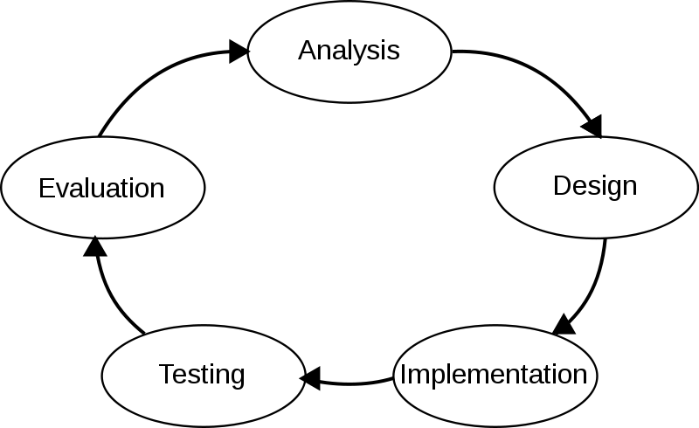

A system analysis is a separation of a substance into parts for study and their implementation and detailed examination.

Before designing any system it is important that the nature of the business and the way it currently operates are clearly understood. The detailed examination provides the specific data required during designing in order to ensure that all the client's requirements are fulfilled. The investigation or the study conducted during the analysis phase is largely based on the feasibility study. Rather it would not be wrong to say that the analysis and feasibility phases overlap. High-level analysis begins during the feasibility study. Though analysis is represented as one phase of the system development life cycle (SDLC), this is not true. Analysis begins with system initialization and continues until its maintenance. Even after successful implementation of the system, analysis may play its role for periodic maintenance and up gradation of the system.

One of the main causes of project failures is inadequate understanding, and one of the main causes of inadequate understanding of the requirements is the poor planning of system analysis.

Analysis requires us to recall the objectives of the project and consider following three questions:

* What type of information is required?
* What are the constraints on the investigation?
* What are the potential problems that may make the task more difficult?

**10. ERD, DFD**

**CONTEXT LEVEL DFD FOR**

**ONLINE PIZZA ORDER BOOKING SYSTEM**

Customer

Update order

States

Add Sub Cartages

Add Cartages

Get

Orders

View Feedback

Admin

Place order

Response

Services

Give

Feedback

Request Services

View Cartages

**Ist Level DFD for ONLINE PIZZA ORDER BOOKING SYSTEM**

Get Reports

Admin

Update

order

Order

D4

Sub Category

D3

Feedbacks

D5

C name

Customer id,

Sub Category

Update

Customer

Update Sub

category

Order id,

User name, adders 

Customer_name

Category id,

Category

Update

C name

Category _id,

Verify User

Password

Username,

Category

D2

order

D4

Subcategory Category

D3

Customer

D5

Category

D2

Order

D4

Admin

D1

**II nd LEVEL DFD FOR ADMIN**

Admin

**Online Pizza Order Booking System**

Verify user

Re-Enter username if In valid

If valid user

Admin Login

**III nd LEVEL DFD FOR THE CUSTOMER**

Customer

Enter

User name password

D1 Customer

In valid User

In valid User

Re enter details

Place order

D2 Customer

D3 Order

**ER-DIAGRAM**

Deliver

Place

Customer

Order

Order

has

Category

has

Add

Sub Category

Give

Feed back

View

Customer

Admin

Add

**Use Case Diagram**

**Admin**

**Customer**

**CLASS DIAGRAM**

Item_ID

Item details ()

**Item**

Image

Amount

Type

Category

Address

Basic

Comment

ID

**Feedback**

Online Shoppimg

Country

View Products

Payment Mode

Date of Delivery

Bill_Generation()

Bill Date

Bill No

Bill_Generation()

**Bill**

Price

Status

Amount

USER_ID

ID

**Order Details**

Category_name

Category_ID

Password

User Name

Login ()

Add_Categories()

Add_Items ()

Verify_User ()

**Admin**

Address

City

Email

Password

ID

Login()

Add to Cart()

View Product()

**Customer**

Name

Feedback

**Category**

Give feedbacks

Bill Generation

**11.  INPUT AND OUTPUT SCREEN DESIGN**

**5.1 SOURCE CODE**

**Index.php**

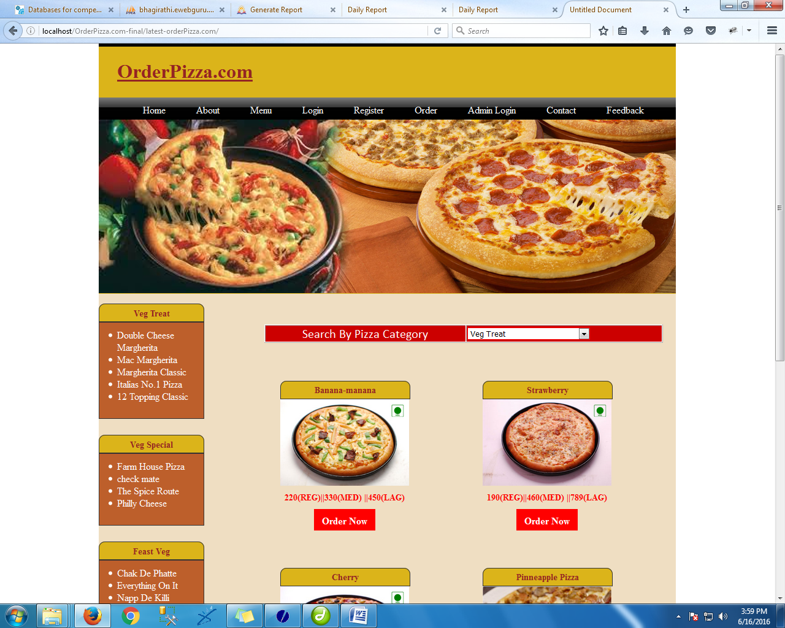

<!DOCTYPE html PUBLIC "-//W3C//DTD XHTML 1.0 Transitional//EN" "http://www.w3.org/TR/xhtml1/DTD/xhtml1-transitional.dtd">

<html xmlns="http://www.w3.org/1999/xhtml">

<head>

<meta http-equiv="Content-Type" content="text/html; charset=iso-8859-1" />

<title>Untitled Document</title>

<link href="css/style.css" rel="stylesheet" type="text/css" />

<script type="text/javascript" language="javascript" src="js/jquery-1.10.2.min.js"></script>

<script type="text/javascript">

function getResult(str)

{

jQuery.ajax({

type: "GET",

url: "ajax_result.php",

data: "catId=" + str,

success: function(data)

{

$("#show").html(data);

},

error: function()

{

$("#show").html('loading Result..');

}

});

}

</script>

</head>

<body>

<div class="main" >

<?php include('header.php');

?>

<div class="body">

<div class="adminleft">

<?php include('left.php'); ?>

</div>

<table border="1" bgcolor="#CC0000" style="margin-top:50px; margin-left:270px; width:650px; color:#fff; background-color:#CC0000; height:30px" align="center"><tr><td valign="middle" align="center">Search By Pizza Category</td><td valign="middle">

<select name="cat" onchange="getResult(this.value);">

<?php

include('config.php');

$result=mysql_query("SELECT * FROM category");

while($row=mysql_fetch_array($result))

{

$cat=$row['catName'];

?>

<option value="<?php echo $row['id']; ?>-<?php echo $row['catName']; ?>"><?php echo $row['catName']; ?></option>

<?php

}

?>

</select></td></tr></table>

<br /><div class="adminright" id="show" >

<br>

<h2 style=" margin-left:28px; margin-right:10px;color:#942423"></h2>

<?php

$scat=mysql_Query("Select * from subcategory order by id desc limit 6 ");

while($r=mysql_fetch_array($scat))

{

?>

<div class="boxindex" style="margin-right:50px">

<h4 class="h1class2"><?php echo $r['sname'];?></h4><img src="<?php echo $r['path'];?>" width="75%" style="margin-bottom:10px">

<span style="font-size:14px"><?php echo $r['personal_price'];?>(REG)||<?php echo $r['medium_price'];?>(MED) ||<?php echo $r['family_price'];?>(LAG)</span>

<center><a href="pizzaMore.php?id=<?php echo $r['id']; ?>&cat=<?php echo $r['cname'];?>" style="text-decoration:none"><div class="button2">Order Now</div></a></center>

</div>

<?php

}

?>

</div>

</div>

<?php include('footer.php'); ?>

</div>

</div>

</body>

</html>

**AboutUs.php**

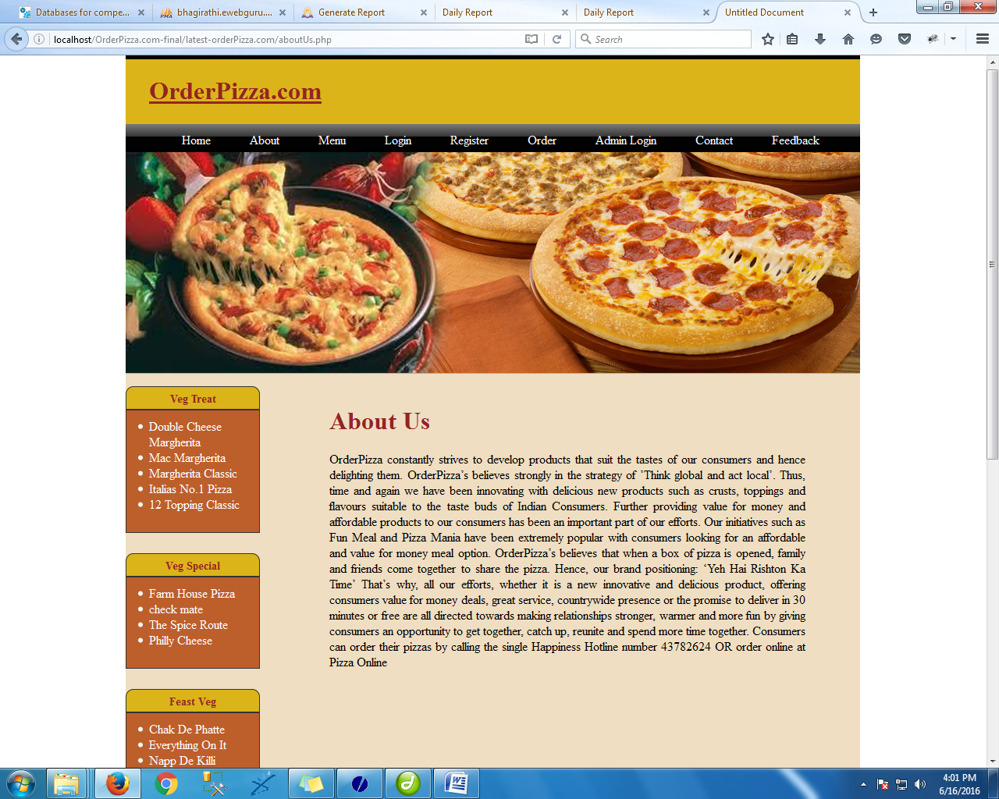

<!DOCTYPE html PUBLIC "-//W3C//DTD XHTML 1.0 Transitional//EN" "http://www.w3.org/TR/xhtml1/DTD/xhtml1-transitional.dtd">

<html xmlns="http://www.w3.org/1999/xhtml">

<head>

<meta http-equiv="Content-Type" content="text/html; charset=iso-8859-1" />

<title>Untitled Document</title>

<link href="css/style.css" rel="stylesheet" type="text/css" />

</head>

<body>

<div class="main" >

<?php include('header.php');

?>

<div class="body">

<div class="adminleft">

<?php include('left.php'); ?>

</div>

<div class="adminright">

<br />

<h1 style=" margin-left:0px; margin-right:10px;color:#942423">About Us</h1>

<p style="text-align: justify; margin-left:0px; margin-right:70px">OrderPizza constantly strives to develop products that suit the tastes of our consumers and hence delighting them. OrderPizza’s believes strongly in the strategy of ’Think global and act local’. Thus, time and again we have been innovating with delicious new products such as crusts, toppings and flavours suitable to the taste buds of Indian Consumers. Further providing value for money and affordable products to our consumers has been an important part of our efforts. Our initiatives such as Fun Meal and Pizza Mania have been extremely popular with consumers looking for an affordable and value for money meal option.

OrderPizza’s believes that when a box of pizza is opened, family and friends come together to share the pizza. Hence, our brand positioning: ‘Yeh Hai Rishton Ka Time’

That’s why, all our efforts, whether it is a new innovative and delicious product, offering consumers value for money deals, great service, countrywide presence or the promise to deliver in 30 minutes or free are all directed towards making relationships stronger, warmer and more fun by giving consumers an opportunity to get together, catch up, reunite and spend more time together.

Consumers can order their pizzas by calling the single Happiness Hotline number 43782624 OR order online at Pizza Online</p>

</div></div>

<?php include('footer.php');

?>

</div>

</div>

</body>

</html>

**Contactus.php**

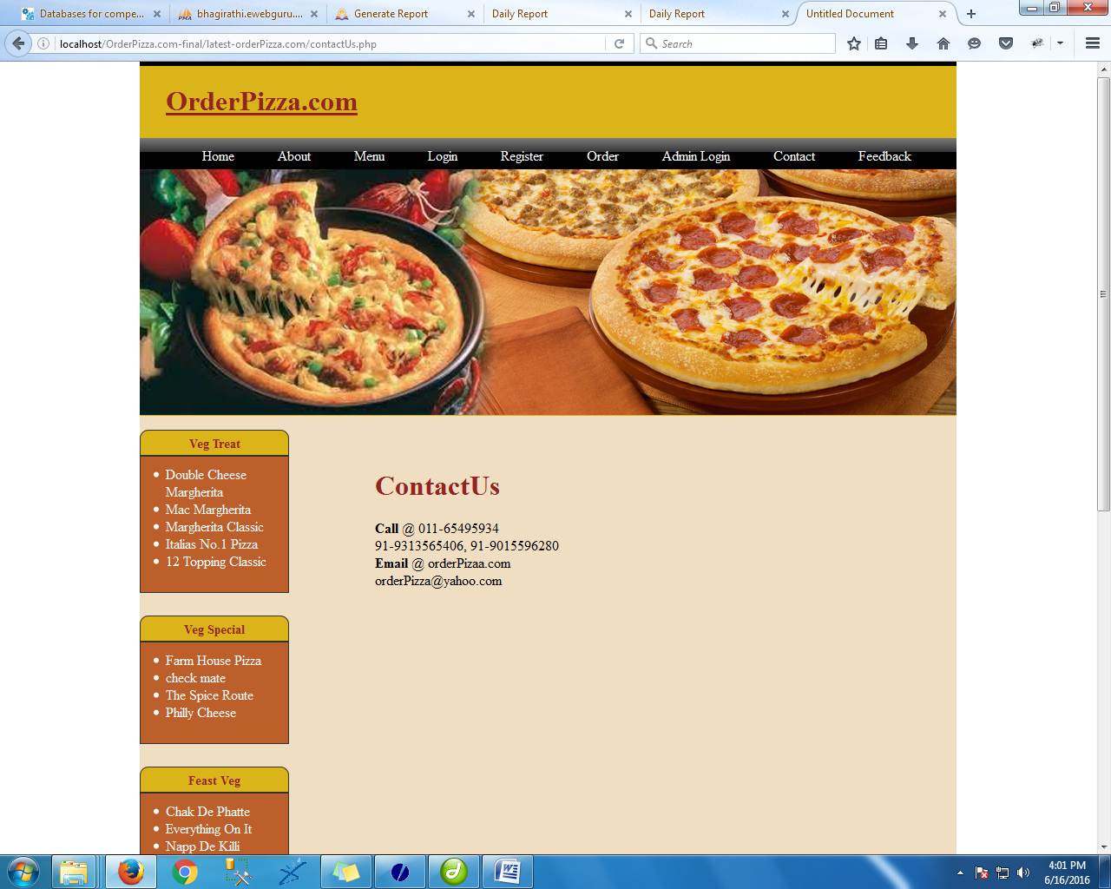

<!DOCTYPE html PUBLIC "-//W3C//DTD XHTML 1.0 Transitional//EN" "http://www.w3.org/TR/xhtml1/DTD/xhtml1-transitional.dtd">

<html xmlns="http://www.w3.org/1999/xhtml">

<head>

<meta http-equiv="Content-Type" content="text/html; charset=iso-8859-1" />

<title>Untitled Document</title>

<link href="css/style.css" rel="stylesheet" type="text/css" />

</head>

<body>

<div class="main" >

<?php include('header.php');

?>

<div class="body">

<div class="adminleft">

<?php include('left.php'); ?>

</div>

<br />

<div class="adminright">

<br />

<h1 style=" margin-left:10px; margin-right:10px;color:#942423">ContactUs</h1>

<p style="text-align: justify; margin-left:10px; margin-right:10px">

<b>Call </b>@ 011-65495934<br />

91-9313565406, 91-9015596280<br />

<b>Email</b> @ orderPizaa.com<br />

orderPizza@yahoo.com

</p>

</div></div>

<?php include('footer.php');

?>

</div>

</div>

</body>

</html>

**Feed_details.php**

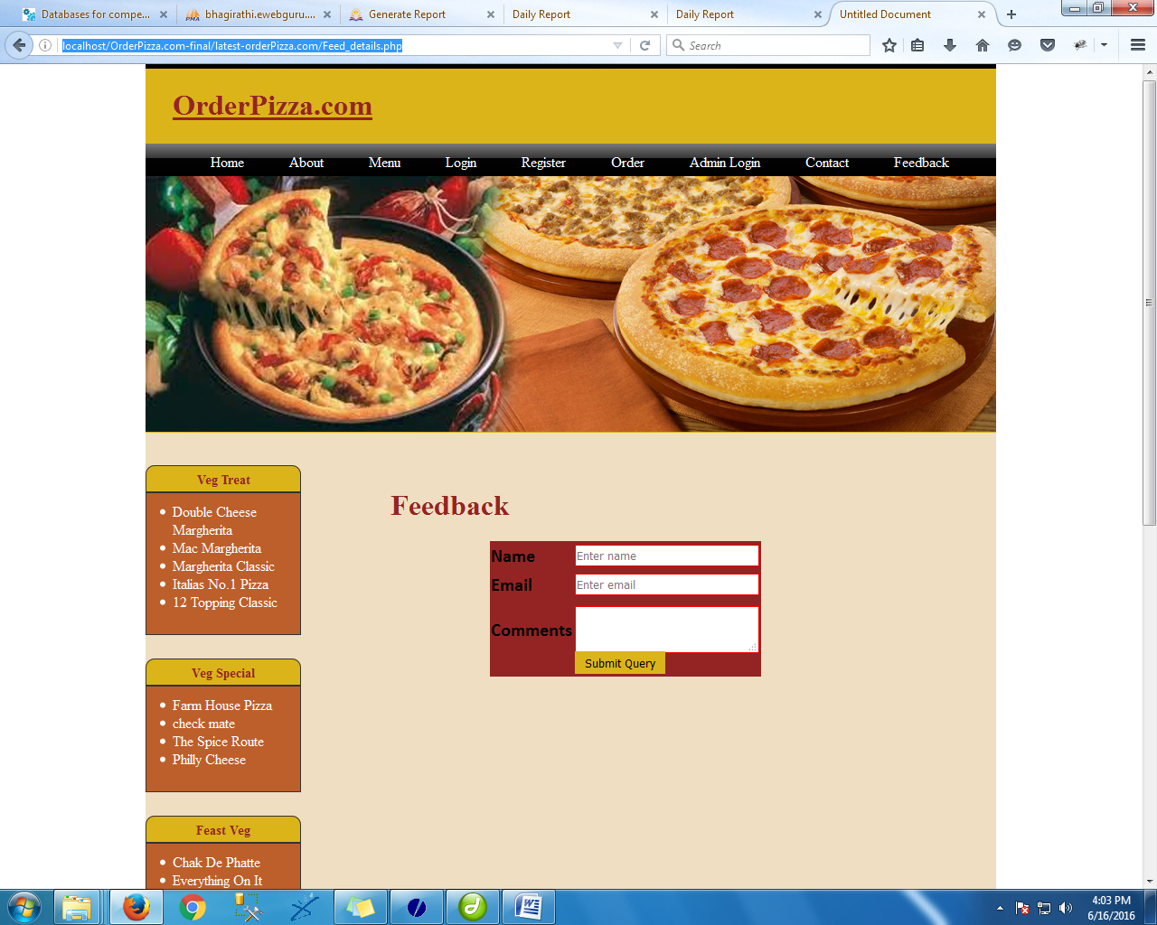

<!DOCTYPE html PUBLIC "-//W3C//DTD XHTML 1.0 Transitional//EN" "http://www.w3.org/TR/xhtml1/DTD/xhtml1-transitional.dtd">

<html xmlns="http://www.w3.org/1999/xhtml">

<head>

<meta http-equiv="Content-Type" content="text/html; charset=iso-8859-1" />

<title>Untitled Document</title>

<link href="css/style.css" rel="stylesheet" type="text/css" />

</head>

<body>

<div class="main" >

<?php include('header.php');

?>

<div class="body">

<br />

<div class="adminleft">

<?php include('left.php'); ?>

</div>

<div class="adminright">

<br />

<h1 style=" margin-left:10px; margin-right:10px;color:#942423"><b>Feedback</b></h1>

<form action="feed_action.php" method="post">

<table border="0" bordercolor="black" bgcolor="#942423" width="300" height="150" style="margin-left:120px">

<tr>

<td><b>Name</b></td><td><input type="text" name="name" placeholder="Enter name"/></td>

</tr>

<tr>

<td><b>Email</b></td><td><input type="text" name="em" placeholder="Enter email" /></td>

</tr>

<tr>

<th>Comments</th>

<td>

<textarea name="com" rows="5" cols="15"></textarea></td>

</tr>

<td></td><td><input type="submit" class="button" style="background-color:#DBB41A; color:#000000; border:#000000"/></td>

</tr>

</table>

</form>

</div></div>

<?php include('footer.php');

?>

</div>

</body>

</html>

**register.php**

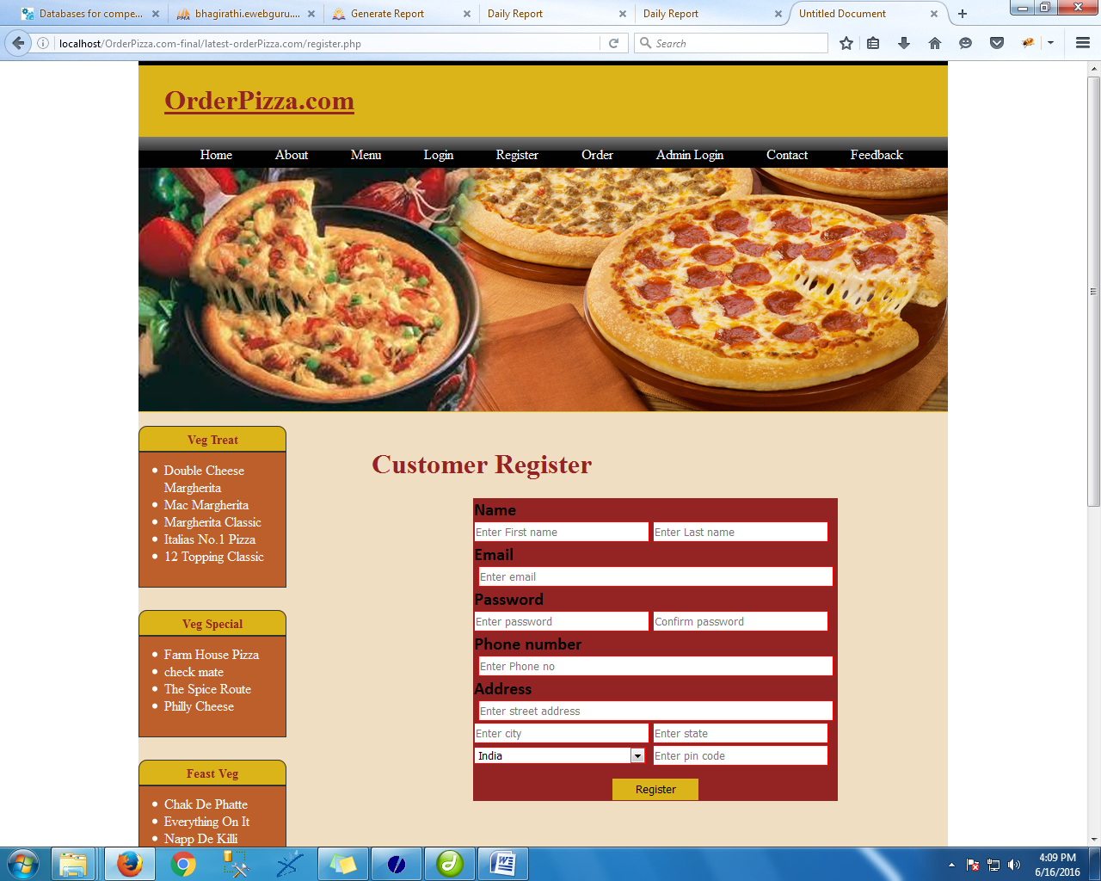

<!DOCTYPE html PUBLIC "-//W3C//DTD XHTML 1.0 Transitional//EN" "http://www.w3.org/TR/xhtml1/DTD/xhtml1-transitional.dtd">

<html xmlns="http://www.w3.org/1999/xhtml">

<head>

<meta http-equiv="Content-Type" content="text/html; charset=iso-8859-1" />

<title>Untitled Document</title>

<link href="css/style.css" rel="stylesheet" type="text/css" />

</head>

<body>

<div class="main" >

<?php include('header.php');

?>

<div class="body">

<div class="adminleft">

<?php include('left.php');

?>

</div>

<div class="adminright">

<br />

<h1 style=" margin-left:10px; margin-right:10px;color:#942423">Customer Register</h1>

<form action="register_action.php" method="post">

<table align="center" border="0" bordercolor="black" bgcolor="#942423" width="424" height="300" style="border:thick; border:#000000">

<tr>

<td width="202"><b>Name</b></td>

</tr>

<tr>

<td><input type="text" name="na" placeholder="Enter First name"/></td>

<td width="212"><input type="text" name="na" placeholder="Enter Last name"/></td>

</tr>

<tr>

<tr>

<td><b>Email</b></td>

</tr>

<tr>

<td colspan="2"><input type="text" name="em" placeholder="Enter email" style="width:97%; margin-left:5px"></td>

</tr>

<tr>

<td><b>Password</b></td>

</tr>

<tr>

<td><input type="password" name="ps" placeholder="Enter password" /></td>

<td><input type="password" name="ps" placeholder="Confirm password" /></td>

</tr>

<tr>

<td><b>Phone number</b></td>

</tr>

<tr>

<td colspan="2"><input type="text" name="ph" placeholder="Enter Phone no" style="width:97%;margin-left:5px"></td>

</tr>

<tr>

<td><b>Address</b></td>

</tr>

<tr>

<td colspan="2"><input type="text" name="add" placeholder="Enter street address" style="width:97%;margin-left:5px"></td>

</tr>

<tr>

<td><input type="text" name="add" placeholder="Enter city"/></td>

<td><input type="text" name="add" placeholder="Enter state"/></td>

</tr>

<tr>

<td><select name="country">

<option value="Select">Select</option>

<option value="Afghanistan">Afghanistan</option>

<option value="Albania">Albania</option>

<option value="Algeria">Algeria</option>

<option value="Andorra">Andorra</option>

<option value="Antigua and Barbuda">Antigua and Barbuda</option>

<option value="Argentina">Argentina</option>

<option value="Armenia">Armenia</option>

<option value="Australia">Australia</option>

<option value="Austria">Austria</option>

<option value="Azerbaijan">Azerbaijan</option>

<option value="Bahamas">Bahamas</option>

<option value="Bahrain">Bahrain</option>

<option value="Bangladesh">Bangladesh</option>

<option value="Barbados">Barbados</option>

<option value="Belarus">Belarus</option>

<option value="Belgium">Belgium</option>

<option value="Belize">Belize</option>

<option value="Benin">Benin</option>

<option value="Bhutan">Bhutan</option>

<option value="Bolivia">Bolivia</option>

<option value="Bosnia and Herzegovina">Bosnia and Herzegovina</option>

<option value="Botswana">Botswana</option>

<option value="Brazil">Brazil</option>

<option value="Brunei">Brunei</option>

<option value="Bulgaria">Bulgaria</option>

<option value="Burkina Faso">Burkina Faso</option>

<option value="Burundi">Burundi</option>

<option value="Cambodia">Cambodia</option>

<option value="Cameroon">Cameroon</option>

<option value="Canada">Canada</option>

<option value="Cape Verde">Cape Verde</option>

<option value="Central African Republic">Central African Republic</option>

<option value="Chad">Chad</option>

<option value="Chile">Chile</option>

<option value="China">China</option>

<option value="Colombia">Colombia</option>

<option value="Comoros">Comoros</option>

<option value="Congo">Congo</option>

<option value="Costa Rica">Costa Rica</option>

<option value="Côte d'Ivoire">Côte d'Ivoire</option>

<option value="Croatia">Croatia</option>

<option value="Cuba">Cuba</option>

<option value="Cyprus">Cyprus</option>

<option value="Czech Republic">Czech Republic</option>

<option value="Denmark">Denmark</option>

<option value="Djibouti">Djibouti</option>

<option value="Dominica">Dominica</option>

<option value="Dominican Republic">Dominican Republic</option>

<option value="East Timor">East Timor</option>

<option value="Ecuador">Ecuador</option>

<option value="Egypt">Egypt</option>

<option value="El Salvador">El Salvador</option>

<option value="Equatorial Guinea">Equatorial Guinea</option>

<option value="Eritrea">Eritrea</option>

<option value="Estonia">Estonia</option>

<option value="Ethiopia">Ethiopia</option>

<option value="Fiji">Fiji</option>

<option value="Finland">Finland</option>

<option value="France">France</option>

<option value="Gabon">Gabon</option>

<option value="Gambia">Gambia</option>

<option value="Georgia">Georgia</option>

<option value="Germany">Germany</option>

<option value="Ghana">Ghana</option>

<option value="Greece">Greece</option>

<option value="Grenada">Grenada</option>

<option value="Guatemala">Guatemala</option>

<option value="Guinea">Guinea</option>

<option value="Guinea-Bissau">Guinea-Bissau</option>

<option value="Guyana">Guyana</option>

<option value="Haiti">Haiti</option>

<option value="Honduras">Honduras</option>

<option value="Hong Kong">Hong Kong</option>

<option value="Hungary">Hungary</option>

<option value="Iceland">Iceland</option>

<option value="India" selected="selected" name="India">India</option>

<option value="Indonesia">Indonesia</option>

<option value="Iran">Iran</option>

<option value="Iraq">Iraq</option>

<option value="Ireland">Ireland</option>

<option value="Israel">Israel</option>

<option value="Italy">Italy</option>

<option value="Jamaica">Jamaica</option>

<option value="Japan">Japan</option>

<option value="Jordan">Jordan</option>

<option value="Kazakhstan">Kazakhstan</option>

<option value="Kenya">Kenya</option>

<option value="Kiribati">Kiribati</option>

<option value="North Korea">North Korea</option>

<option value="South Korea">South Korea</option>

<option value="Kuwait">Kuwait</option>

<option value="Kyrgyzstan">Kyrgyzstan</option>

<option value="Laos">Laos</option>

<option value="Latvia">Latvia</option>

<option value="Lebanon">Lebanon</option>

<option value="Lesotho">Lesotho</option>

<option value="Liberia">Liberia</option>

<option value="Libya">Libya</option>

<option value="Liechtenstein">Liechtenstein</option>

<option value="Lithuania">Lithuania</option>

<option value="Luxembourg">Luxembourg</option>

<option value="Macedonia">Macedonia</option>

<option value="Madagascar">Madagascar</option>

<option value="Malawi">Malawi</option>

<option value="Malaysia">Malaysia</option>

<option value="Maldives">Maldives</option>

<option value="Mali">Mali</option>

<option value="Malta">Malta</option>

<option value="Marshall Islands">Marshall Islands</option>

<option value="Mauritania">Mauritania</option>

<option value="Mauritius">Mauritius</option>

<option value="Mexico">Mexico</option>

<option value="Micronesia">Micronesia</option>

<option value="Moldova">Moldova</option>

<option value="Monaco">Monaco</option>

<option value="Mongolia">Mongolia</option>

<option value="Montenegro">Montenegro</option>

<option value="Morocco">Morocco</option>

<option value="Mozambique">Mozambique</option>

<option value="Myanmar">Myanmar</option>

<option value="Namibia">Namibia</option>

<option value="Nauru">Nauru</option>

<option value="Nepal">Nepal</option>

<option value="Netherlands">Netherlands</option>

<option value="New Zealand">New Zealand</option>

<option value="Nicaragua">Nicaragua</option>

<option value="Niger">Niger</option>

<option value="Nigeria">Nigeria</option>

<option value="Norway">Norway</option>

<option value="Oman">Oman</option>

<option value="Pakistan">Pakistan</option>

<option value="Palau">Palau</option>

<option value="Panama">Panama</option>

<option value="Papua New Guinea">Papua New Guinea</option>

<option value="Paraguay">Paraguay</option>

<option value="Peru">Peru</option>

<option value="Philippines">Philippines</option>

<option value="Poland">Poland</option>

<option value="Portugal">Portugal</option>

<option value="Puerto Rico">Puerto Rico</option>

<option value="Qatar">Qatar</option>

<option value="Romania">Romania</option>

<option value="Russia">Russia</option>

<option value="Rwanda">Rwanda</option>

<option value="Saint Kitts and Nevis">Saint Kitts and Nevis</option>

<option value="Saint Lucia">Saint Lucia</option>

<option value="Samoa">Samoa</option>

<option value="San Marino">San Marino</option>

<option value="Sao Tome and Principe">Sao Tome and Principe</option>

<option value="Saudi Arabia">Saudi Arabia</option>

<option value="Senegal">Senegal</option>

<option value="Serbia and Montenegro">Serbia and Montenegro</option>

<option value="Seychelles">Seychelles</option>

<option value="Sierra Leone">Sierra Leone</option>

<option value="Singapore">Singapore</option>

<option value="Slovakia">Slovakia</option>

<option value="Slovenia">Slovenia</option>

<option value="Solomon Islands">Solomon Islands</option>

<option value="Somalia">Somalia</option>

<option value="South Africa">South Africa</option>

<option value="Spain">Spain</option>

<option value="Sri Lanka">Sri Lanka</option>

<option value="Sudan">Sudan</option>

<option value="Suriname">Suriname</option>

<option value="Swaziland">Swaziland</option>

<option value="Sweden">Sweden</option>

<option value="Switzerland">Switzerland</option>

<option value="Syria">Syria</option>

<option value="Taiwan">Taiwan</option>

<option value="Tajikistan">Tajikistan</option>

<option value="Tanzania">Tanzania</option>

<option value="Thailand">Thailand</option>

<option value="Togo">Togo</option>

<option value="Tonga">Tonga</option>

<option value="Trinidad and Tobago">Trinidad and Tobago</option>

<option value="Tunisia">Tunisia</option>

<option value="Turkey">Turkey</option>

<option value="Turkmenistan">Turkmenistan</option>

<option value="Tuvalu">Tuvalu</option>

<option value="Uganda">Uganda</option>

<option value="Ukraine">Ukraine</option>

<option value="United Arab Emirates">United Arab Emirates</option>

<option value="United Kingdom">United Kingdom</option>

<option value="United States">United States</option>

<option value="Uruguay">Uruguay</option>

<option value="Uzbekistan">Uzbekistan</option>

<option value="Vanuatu">Vanuatu</option>

<option value="Vatican City">Vatican City</option>

<option value="Venezuela">Venezuela</option>

<option value="Vietnam">Vietnam</option>

<option value="Yemen">Yemen</option>

<option value="Zambia">Zambia</option>

<option value="Zimbabwe">Zimbabwe</option>

</select></td>

<td><input type="text" name="pin" placeholder="Enter pin code"/></td>

</tr>

<tr><td colspan="2"></td></tr>

<tr>

<td colspan="2" align="center"><br /><input type="submit" class="button" value="Register" style="background-color:#DBB41A; color:#000000; border:#000000"/></td>

</tr>

</table><br />

<br />

</form>

</div></div>

<?php include('footer.php');

?>

</div>

</body>

</html>

**cust_log.php**

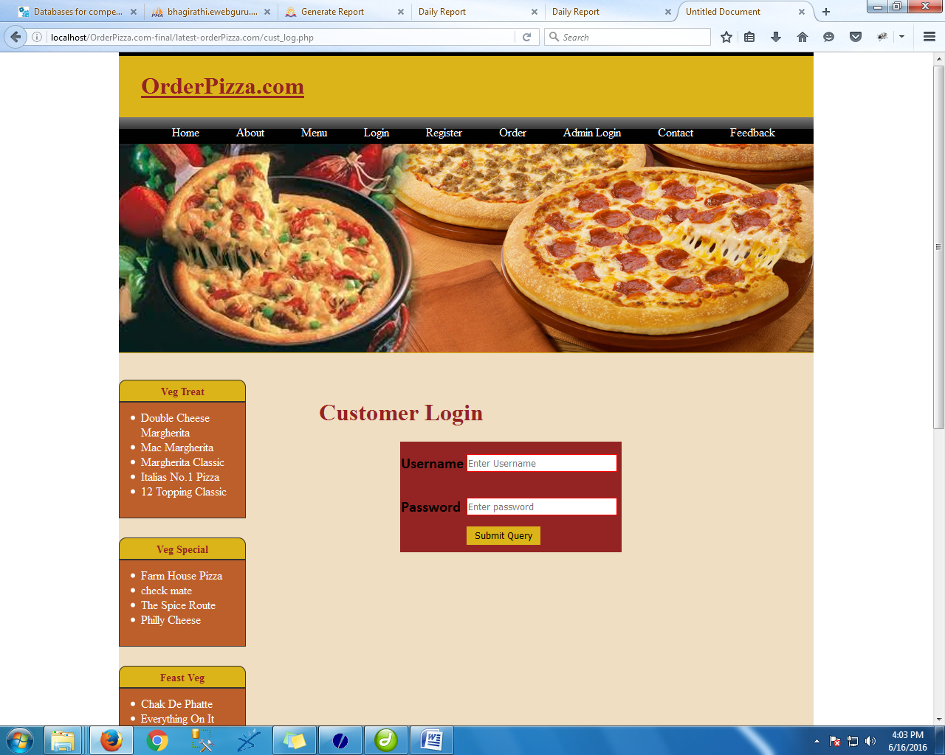

<!DOCTYPE html PUBLIC "-//W3C//DTD XHTML 1.0 Transitional//EN" "http://www.w3.org/TR/xhtml1/DTD/xhtml1-transitional.dtd">

<html xmlns="http://www.w3.org/1999/xhtml">

<head>

<meta http-equiv="Content-Type" content="text/html; charset=iso-8859-1" />

<title>Untitled Document</title>

<link href="css/style.css" rel="stylesheet" type="text/css" />

</head>

<body>

<div class="main" >

<?php include('header.php');

?>

<div class="body">

<br />

<div class="adminleft">

<?php include('left.php'); ?>

</div>

<div class="adminright">

<br />

<h1 style=" margin-left:10px; margin-right:10px;color:#942423">Customer Login</h1>

<?php

if(isset($_GET["ms"]))

{

echo $_GET["ms"];

}

?>

<form action="cust_action.php" method="post">

<table border="0" bordercolor="black" bgcolor="#942423" width="300" height="150" style="margin-left:120px">

<tr>

<td><b>Username</b></td><td><input type="text" name="username" placeholder="Enter Username"/></td>

</tr>

<tr>

<td><b>Password</b></td><td><input type="password" name="password" placeholder="Enter password" /></td>

</tr>

<td></td><td><input type="submit" class="button" style="background-color:#DBB41A; color:#000000; border:#000000"/></td>

<?php

if(isset($_GET['error']))

{

echo $_GET['error'];

}

?>

</tr>

</table>

</form>

</div></div>

<?php include('footer.php');

?>

</div>

</body>

</html>

**admin.php**

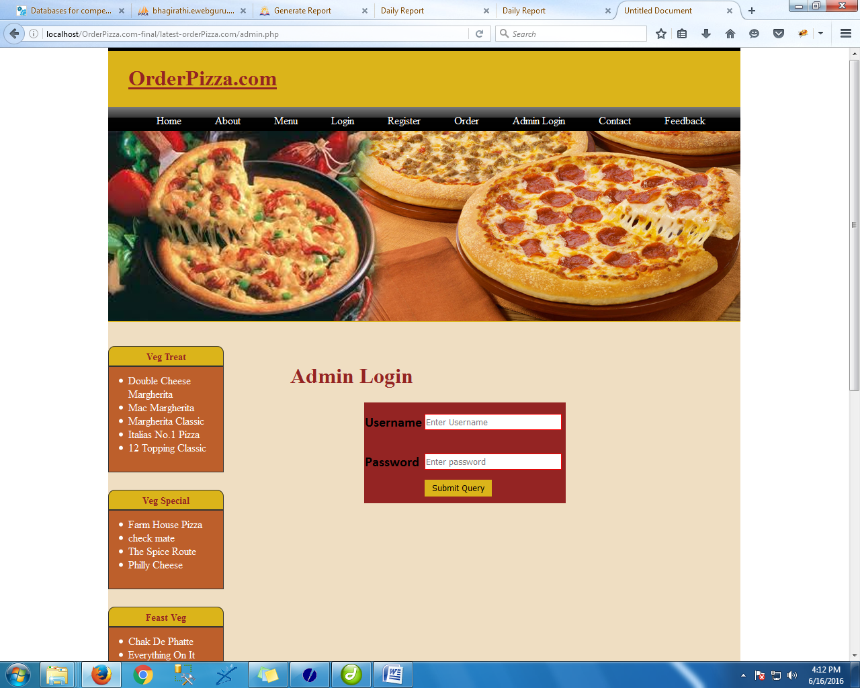

<!DOCTYPE html PUBLIC "-//W3C//DTD XHTML 1.0 Transitional//EN" "http://www.w3.org/TR/xhtml1/DTD/xhtml1-transitional.dtd">

<html xmlns="http://www.w3.org/1999/xhtml">

<head>

<meta http-equiv="Content-Type" content="text/html; charset=iso-8859-1" />

<title>Untitled Document</title>

<link href="css/style.css" rel="stylesheet" type="text/css" />

</head>

<body>

<div class="main" >

<?php include('header.php');

?>

<div class="body">

<br />

<div class="adminleft">

<?php include('left.php'); ?>

</div>

<div class="adminright">

<br />

<h1 style=" margin-left:10px; margin-right:10px;color:#942423">Admin Login</h1>

<form action="adm_action.php" method="post">

<table border="0" bordercolor="black" bgcolor="#942423" width="300" height="150" style="margin-left:120px">

<tr>

<td><b>Username</b></td><td><input type="text" name="usern" placeholder="Enter Username"/></td>

</tr>

<tr>

<td><b>Password</b></td><td><input type="password" name="pass" placeholder="Enter password" /></td>

</tr>

<td></td><td><input type="submit" class="button" style="background-color:#DBB41A; color:#000000; border:#000000"/></td>

<?php

if(isset($_GET['err']))

{

echo $_GET['err'];

}

?>

</tr>

</table>

</form>

</div></div>

<?php include('footer.php');

?>

</div>

</body>

</html>

**adm-welcome.php**

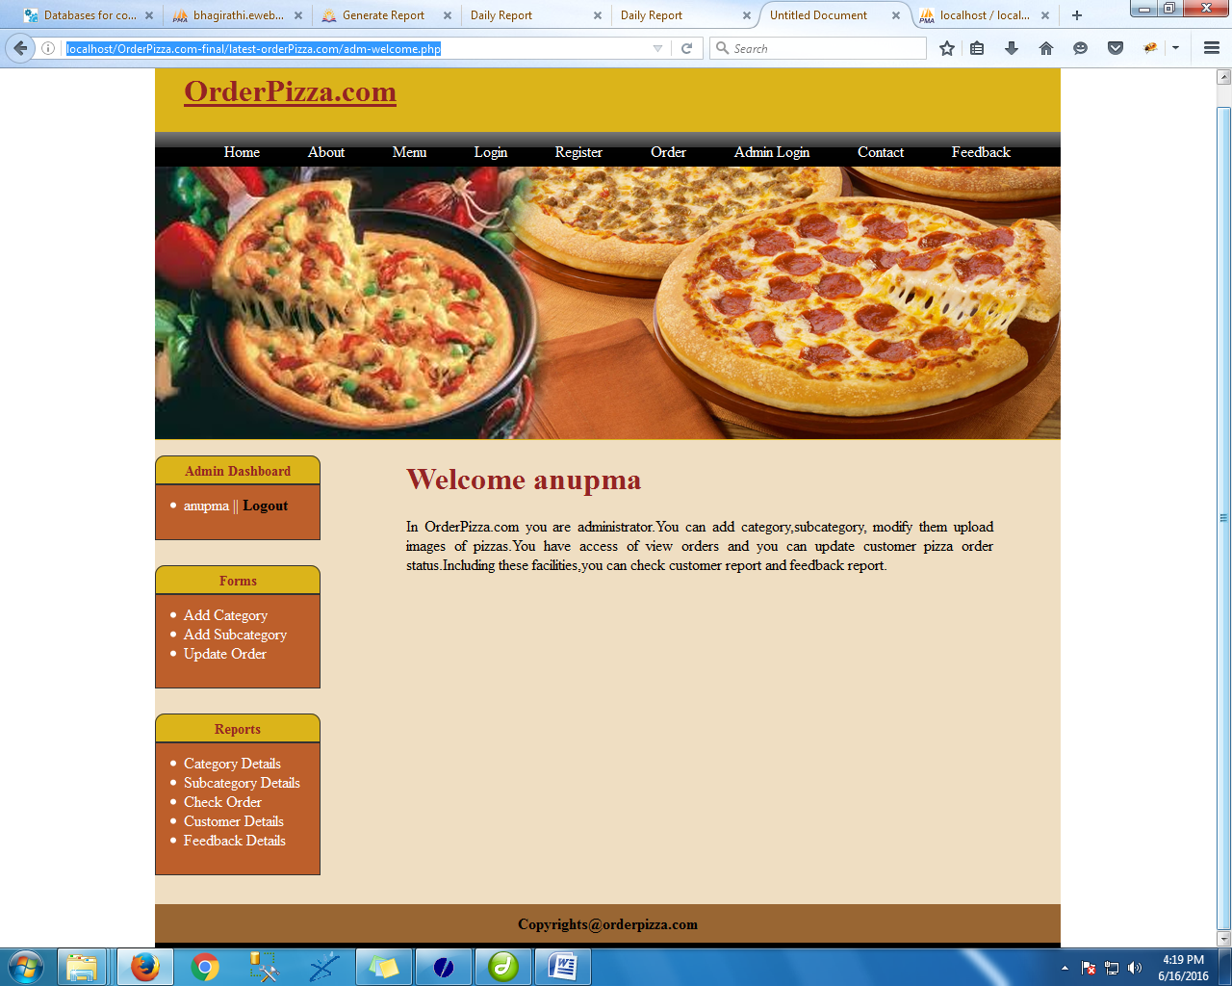

<?php

session_start();

include('adm-lock.php');

?>

<title>Untitled Document</title>

<link href="css/style.css" rel="stylesheet" type="text/css" />

</head>

<body>

<div class="main" >

<?php include('header.php'); ?>

<div class="body">

<div class="adminleft">

<?php include('adminleft.php'); ?>

</div>

<div class="adminright">

<h1 style=" margin-left:0px; margin-right:10px;color:#942423">Welcome <?php

echo $_SESSION['admin_name']."<br>";

?></h1>

<p style="text-align: justify; margin-left:0px; margin-right:70px">In OrderPizza.com you are administrator.You can add category,subcategory, modify them upload images of pizzas.You have access of view orders and you can update customer pizza order status.Including these facilities,you can check customer report and feedback report. </p>

</div>

</div>

<?php include('footer.php'); ?>

</body>

</html>

**add-category.php**

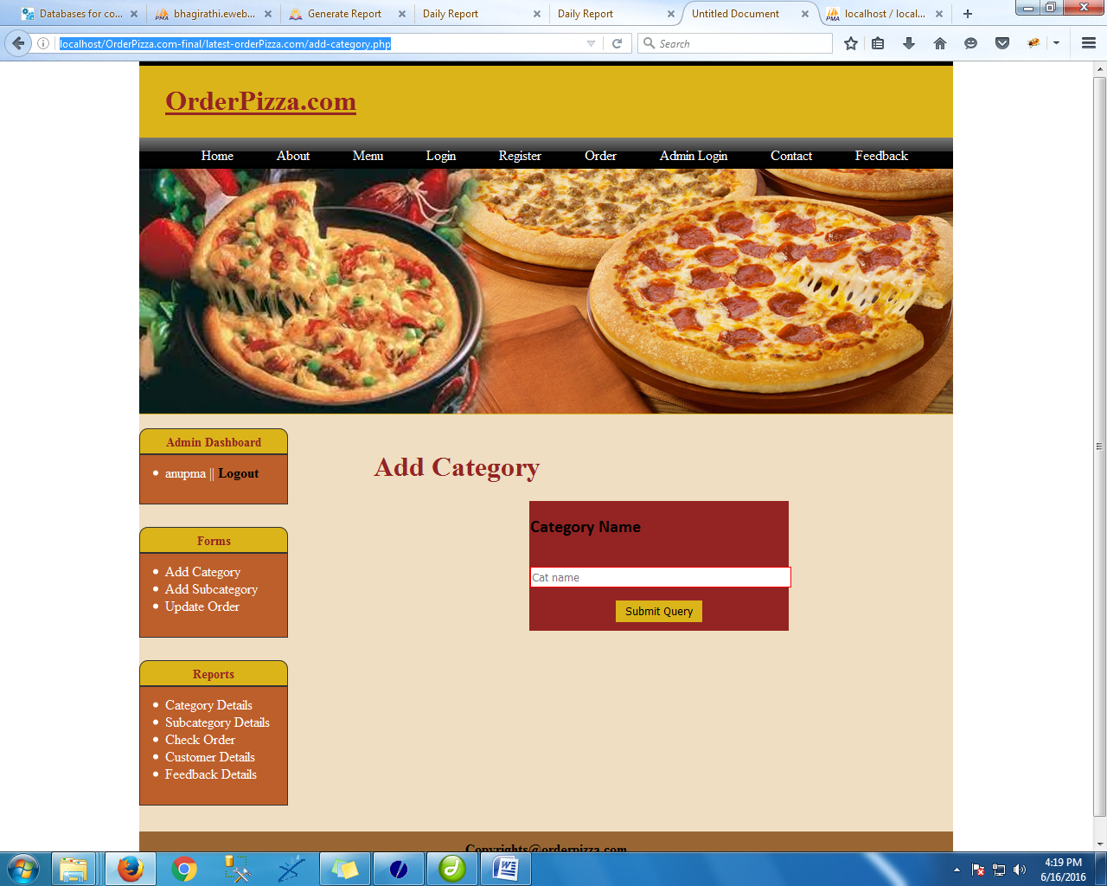

<?php

session_start();

include('adm-lock.php');

?>

<!DOCTYPE html PUBLIC "-//W3C//DTD XHTML 1.0 Transitional//EN" "http://www.w3.org/TR/xhtml1/DTD/xhtml1-transitional.dtd">

<html xmlns="http://www.w3.org/1999/xhtml">

<head>

<meta http-equiv="Content-Type" content="text/html; charset=iso-8859-1" />

<title>Untitled Document</title>

<link href="css/style.css" rel="stylesheet" type="text/css" />

</head>

<body>

<div class="main" >

<?php include('header.php');

?>

<div class="body">

<div class="adminleft">

<?php include('adminleft.php');

?>

</div>

<div class="adminright">

<br />

<h1 style=" margin-left:10px; margin-right:10px;color:#942423">Add Category</h1>

<form action="cat_action.php" method="post">

<table align="center" border="0" bordercolor="black" bgcolor="#942423" width="300" height="150" style="border:thick; border:#000000">

<tr>

<td><b>Category Name</b></td>

</tr>

<tr>

<td colspan="2" ><input type="text" name="cat" placeholder="Cat name"/style="width:100%"> </td>

</tr>

<tr>

<td colspan="2" align="center"><input type="submit" class="button" style="background-color:#DBB41A; color:#000000; border:#000000"/></td>

</tr>

</table><br />

<br />

</form>

</div></div>

<?php include('footer.php');

?>

</div>

</body>

</html>

**cat_Details.php**

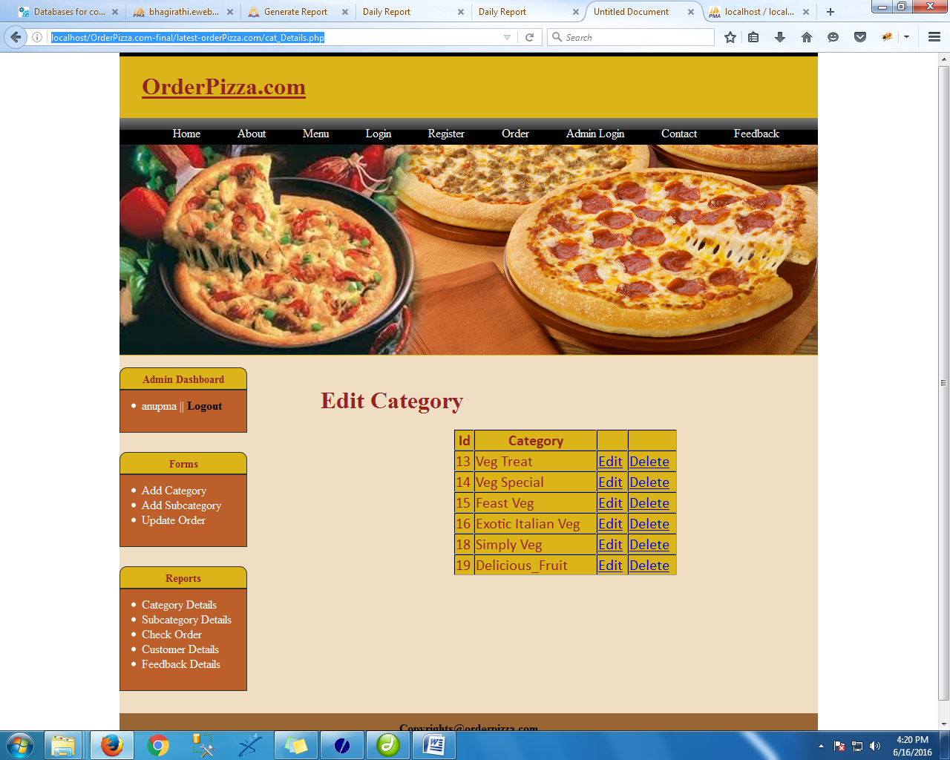

<?php

session_start();

include('adm-lock.php');

?>

<!DOCTYPE html PUBLIC "-//W3C//DTD XHTML 1.0 Transitional//EN" "http://www.w3.org/TR/xhtml1/DTD/xhtml1-transitional.dtd">

<html xmlns="http://www.w3.org/1999/xhtml">

<head>

<meta http-equiv="Content-Type" content="text/html; charset=iso-8859-1" />

<title>Untitled Document</title>

<link href="css/style.css" rel="stylesheet" type="text/css" />

</head>

<body>

<div class="main" >

<?php include('header.php');

?>

<div class="body">

<div class="adminleft">

<?php include('adminleft.php');

?>

</div>

<div class="adminright">

<br />

<h1 style=" margin-left:10px; margin-right:10px;color:#942423">Edit Category</h1>

<table align="center" border="1" bordercolor="black" bgcolor="#DBB41A" width="300" height="150" style="border:thick; color:#942423;border:#000000">

<tr>

<td align="center"><b>Id</b></td>

<td align="center"><b>Category</b></td>

<td></td>

<td></td>

</tr>

<?php

$result=mysql_query("SELECT * FROM category");

while($row=mysql_fetch_array($result))

{

?>

<tr>

<td><?php echo $row['id'];?> </td>

<td><?php echo $row['catName'];?> </td>

<td><a href="edit_cat.php?id=<?php echo $row['id'];?>">Edit</a> </td>

<td><a href="delete_cat.php?id=<?php echo $row['id'];?>">Delete</a> </td>

</tr>

<?php

}

?>

</table>

</div></div>

<?php include('footer.php');

?>

</div>

</body>

</html>

**add-sub.php**

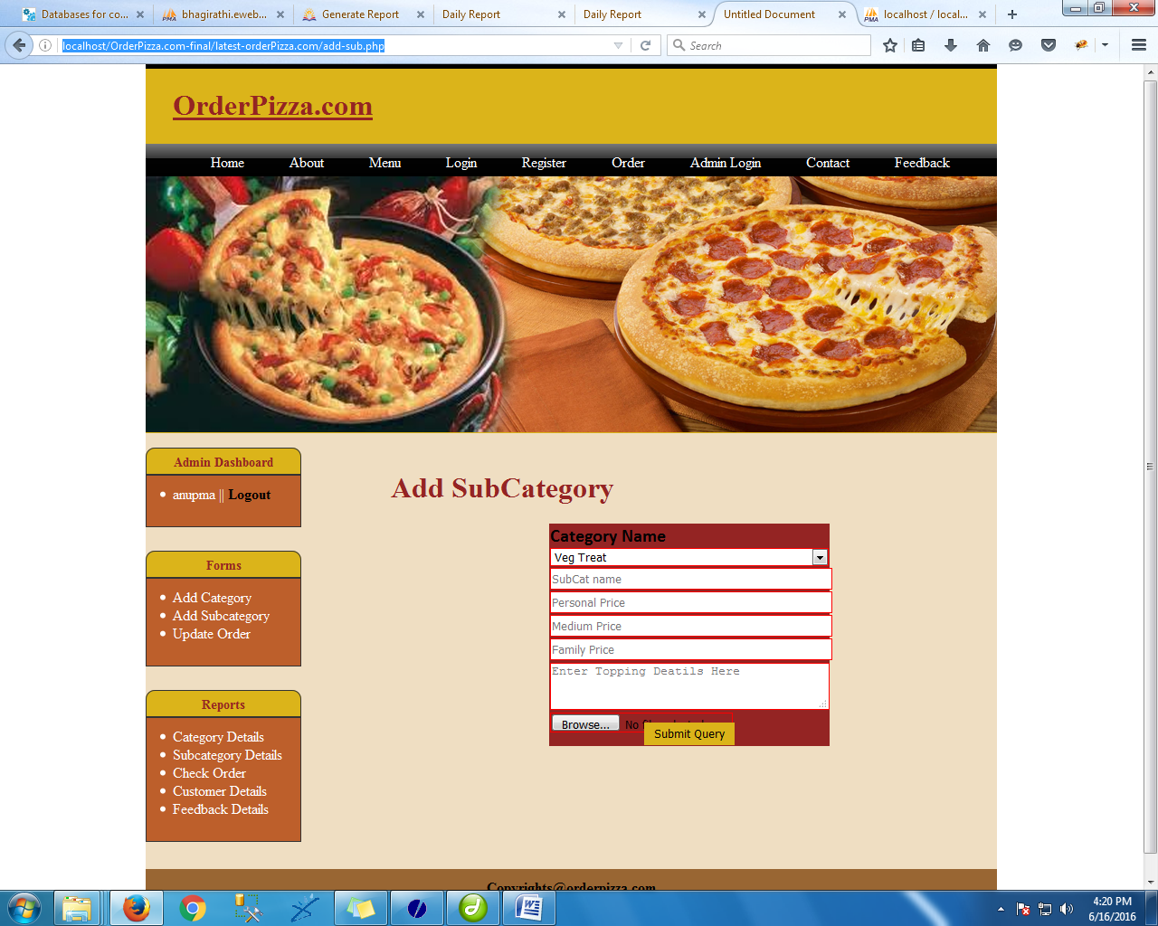

<?php

session_start();

include('adm-lock.php');

?>

<!DOCTYPE html PUBLIC "-//W3C//DTD XHTML 1.0 Transitional//EN" "http://www.w3.org/TR/xhtml1/DTD/xhtml1-transitional.dtd">

<html xmlns="http://www.w3.org/1999/xhtml">

<head>

<meta http-equiv="Content-Type" content="text/html; charset=iso-8859-1" />

<title>Untitled Document</title>

<link href="css/style.css" rel="stylesheet" type="text/css" />

</head>

<body>

<div class="main" >

<?php include('header.php');

?>

<div class="body">

<div class="adminleft">

<?php include('adminleft.php');

?>

</div>

<div class="adminright">

<br />

<h1 style=" margin-left:10px; margin-right:10px;color:#942423">Add SubCategory</h1>

<form action="sub_action.php" method="post" enctype="multipart/form-data">

<table align="center" border="0" bordercolor="black" bgcolor="#942423" width="300" height="150" style="border:thick; border:#000000">

<tr>

<td><b>Category Name</b></td>

</tr>

<tr>

<td colspan="2" ><Select name="cat" style="width:308px">

<?php

$result=mysql_query("SELECT * FROM category");

while($row=mysql_fetch_array($result))

{

?>

<option value="<?php echo $row['id']; ?>-<?php echo $row['catName']; ?>"><?php echo $row['catName']; ?></option>

<?php

}

?>

</Select> </td>

</tr>

<tr>

<td colspan="2" ><input type="text" name="sub" placeholder="SubCat name" style="width:100%"> </td>

</tr>

<tr>

<td colspan="2" ><input type="text" name="p_price" placeholder="Personal Price" style="width:100%"> </td>

</tr>

<tr>

<td colspan="2" ><input type="text" name="m_price" placeholder="Medium Price" style="width:100%"> </td>

</tr>

<tr>

<td colspan="2" ><input type="text" name="f_price" placeholder="Family Price" style="width:100%"> </td>

</tr>

<tr>

<td colspan="2" ><textarea name="toppings" rows="10" cols="20" style="width:99%" Placeholder="Enter Topping Deatils Here"></textarea> </td>

</tr>

<tr>

<td>

<input name="img" type="file" /><br />

</td></tr>

<tr>

<td colspan="2" align="center"><input type="submit" class="button" style="background-color:#DBB41A; color:#000000; border:#000000"/></td>

</tr>

</table>

</form>

</div></div>

<?php include('footer.php');

?>

</div>

</body>

</html>

**sub_Details.php**

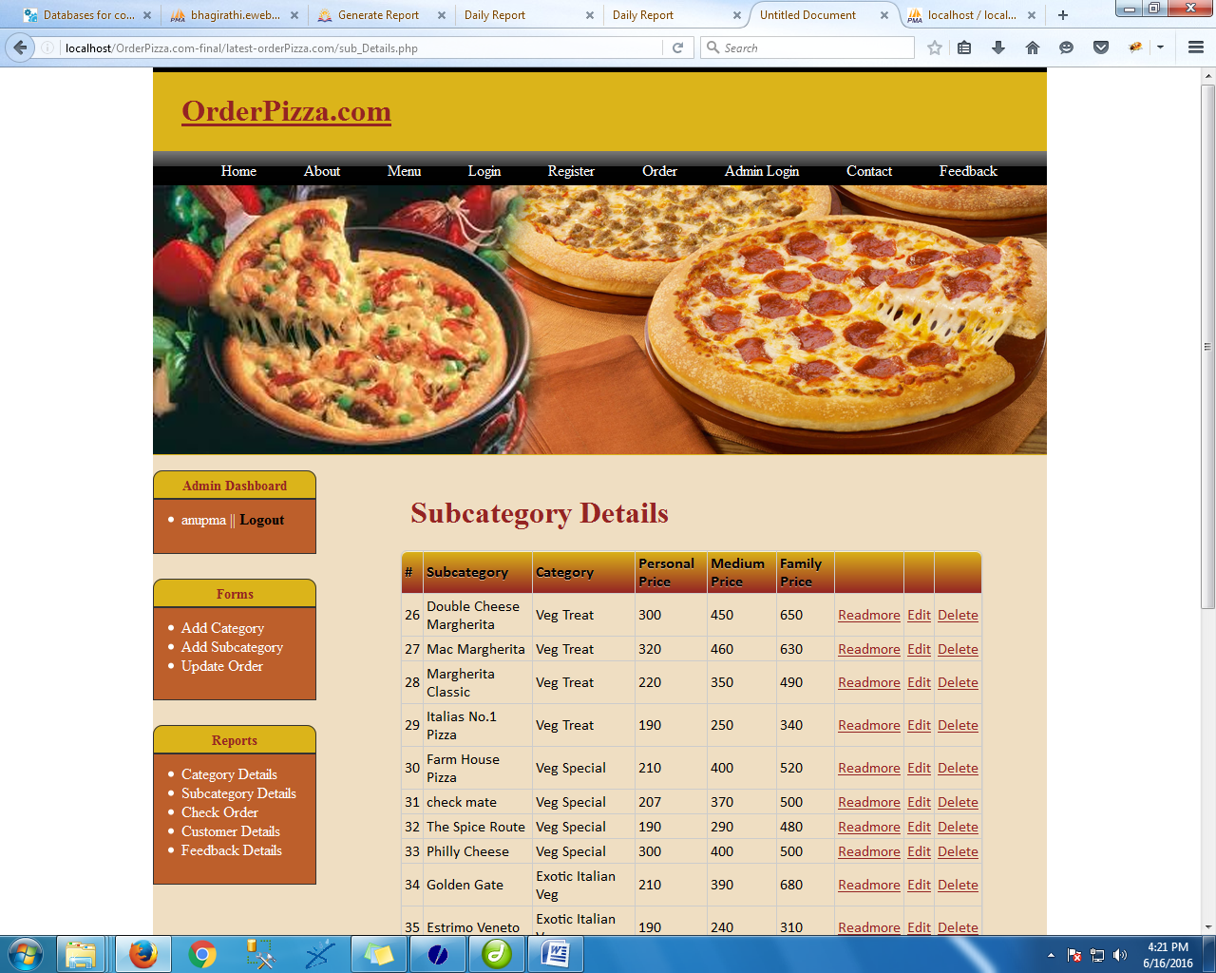

<?php

session_start();

include('adm-lock.php');

?>

<!DOCTYPE html PUBLIC "-//W3C//DTD XHTML 1.0 Transitional//EN" "http://www.w3.org/TR/xhtml1/DTD/xhtml1-transitional.dtd">

<html xmlns="http://www.w3.org/1999/xhtml">

<head>

<meta http-equiv="Content-Type" content="text/html; charset=iso-8859-1" />

<title>Untitled Document</title>

<link href="css/style.css" rel="stylesheet" type="text/css" />

</head>

<body>

<div class="main" >

<?php include('header.php');

?>

<div class="body">

<div class="adminleft">

<?php include('adminleft.php');

?>

</div>

<div class="adminright">

<br />

<h1 style=" margin-left:10px; margin-right:10px;color:#942423"> Subcategory Details</h1>

<table class="bordered" style="font-size:16px;width: 90%;">

<thead>

<tr>

<th>#</th>

<th>Subcategory</th>

<th>Category</th>

<th>Personal Price </th>

<th> Medium Price</th>

<th> Family Price</th>

<th></th><th> </th><th></th>

</tr>

</thead>

<?php

$result=mysql_query("SELECT * FROM subcategory");

while($row=mysql_fetch_array($result))

{

?>

<tr>

<td><?php echo $row['id'];?></td>

<td><?php echo $row['sname'];?> </td>

<td><?php echo $row['cname'];?> </td>

<td><?php echo $row['personal_price'];?> </td>

<td><?php echo $row['medium_price'];?> </td>

<td><?php echo $row['family_price'];?> </td>

<td><a href="readmore.php?src=<?php echo $row['path'];?>&toppings=<?php echo $row['toppings'];?> " style="color:#942423">Readmore</a></td>

<td><a href="edit_subcat.php?id=<?php echo $row['id'];?>" style="color:#942423">Edit</a> </td>

<td><a href="delete_subcat.php?id=<?php echo $row['id'];?>" style="color:#942423">Delete</a> </td>

</tr>

<?php

}

?>

</table>

</div></div>

<?php include('footer.php');

?>

</div>

</body>

</html>

**view_order_history.php**

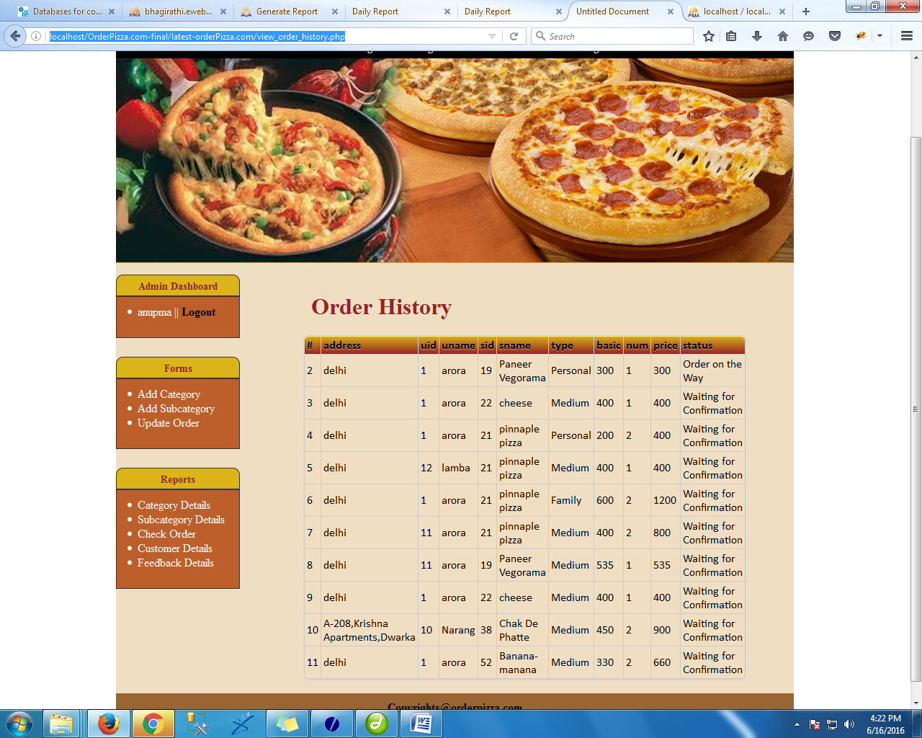

<?php

session_start();

include('adm-lock.php');

?>

<!DOCTYPE html PUBLIC "-//W3C//DTD XHTML 1.0 Transitional//EN" "http://www.w3.org/TR/xhtml1/DTD/xhtml1-transitional.dtd">

<html xmlns="http://www.w3.org/1999/xhtml">

<head>

<meta http-equiv="Content-Type" content="text/html; charset=iso-8859-1" />

<title>Untitled Document</title>

<link href="css/style.css" rel="stylesheet" type="text/css" />

</head>

<body>

<div class="main" >

<?php include('header.php');

?>

<div class="body">

<div class="adminleft">

<?php include('adminleft.php');

?>

</div>

<div class="adminright">

<br />

<h1 style=" margin-left:10px; margin-right:10px;color:#942423"> Order History</h1>

<table class="bordered" style="font-size:16px;width: 90%;">

<thead>

<tr>

<th>#</th>

<th>address</th>

<th>uid</th>

<th>uname</th>

<th>sid</th>

<th>sname </th>

<th>type </th>

<th>basic</th>

<th>num</th>

<th> price</th>

<th>status</th>

</tr>

</thead>

<?php

$rst=mysql_query("SELECT * FROM `order`");

while($ro=mysql_fetch_array($rst))

{

?>

<tr>

<td><?php echo $ro['id'];?> </td>

<td><?php echo $ro['address'];?> </td>

<td><?php echo $ro['uid'];?> </td>

<td><?php echo $ro['uname'];?> </td>

<td><?php echo $ro['sid'];?> </td>

<td><?php echo $ro['sname'];?> </td>

<td><?php echo $ro['type'];?> </td>

<td><?php echo $ro['basic'];?> </td>

<td><?php echo $ro['num'];?> </td>

<td><?php echo $ro['price'];?> </td>

<td><?php echo $ro['status'];?> </td>

</tr>

<?php

}

?>

</table>

</div></div>

<?php include('footer.php');

?>

</div>

</body>

</html>

**updateAction.php**

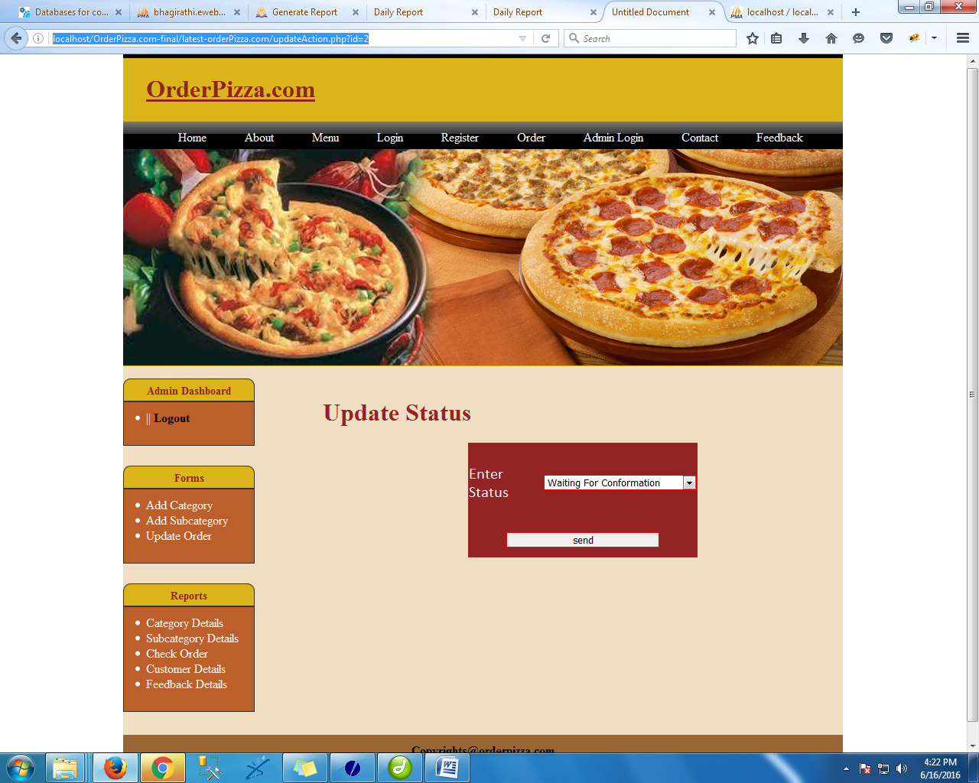

<!DOCTYPE html PUBLIC "-//W3C//DTD XHTML 1.0 Transitional//EN" "http://www.w3.org/TR/xhtml1/DTD/xhtml1-transitional.dtd">

<html xmlns="http://www.w3.org/1999/xhtml">

<head>

<meta http-equiv="Content-Type" content="text/html; charset=iso-8859-1" />

<title>Untitled Document</title>

<link href="css/style.css" rel="stylesheet" type="text/css" />

</head>

<body>

<div class="main" >

<?php include('header.php');

?>

<div class="body">

<div class="adminleft">

<?php include('adminleft.php'); ?>

</div>

<div class="adminright">

<br />

<h1 style=" margin-left:0px; margin-right:10px;color:#942423"><b>Update Status</b></h1>

<?php

$id=$_GET['id'];

?>

<form action="updateStatus.php" method="post">

<input type="hidden" name="oid" value="<?php echo $id; ?>" />

<table align="center" border="0" bordercolor="black" bgcolor="#942423" width="300" height="150" style="border:thick; border:#000000">

<tr>

<tr>

<td style="color:#FFFFFF">Enter Status</td>

<td><select name="sta">

<option value="Waiting For Conformation">Waiting For Conformation</option>

<option value="Preparing Your Order">Preparing Your Order</option>

<option value="Order Packed">Order Packed</option>

<option value="Order on the Way">Order on the Way</option>

<option value="Order Delivered">Order Delivered</option>

</select>

</td>

</tr>

<tr>

<td colspan="2" align="center">

<input type="submit" name="submit" value="send"/>

</td>

</tr>

</table>

</div></div>

<?php include('footer.php');

?>

</div>

</div>

</body>

</html>

**Cust_display.php**

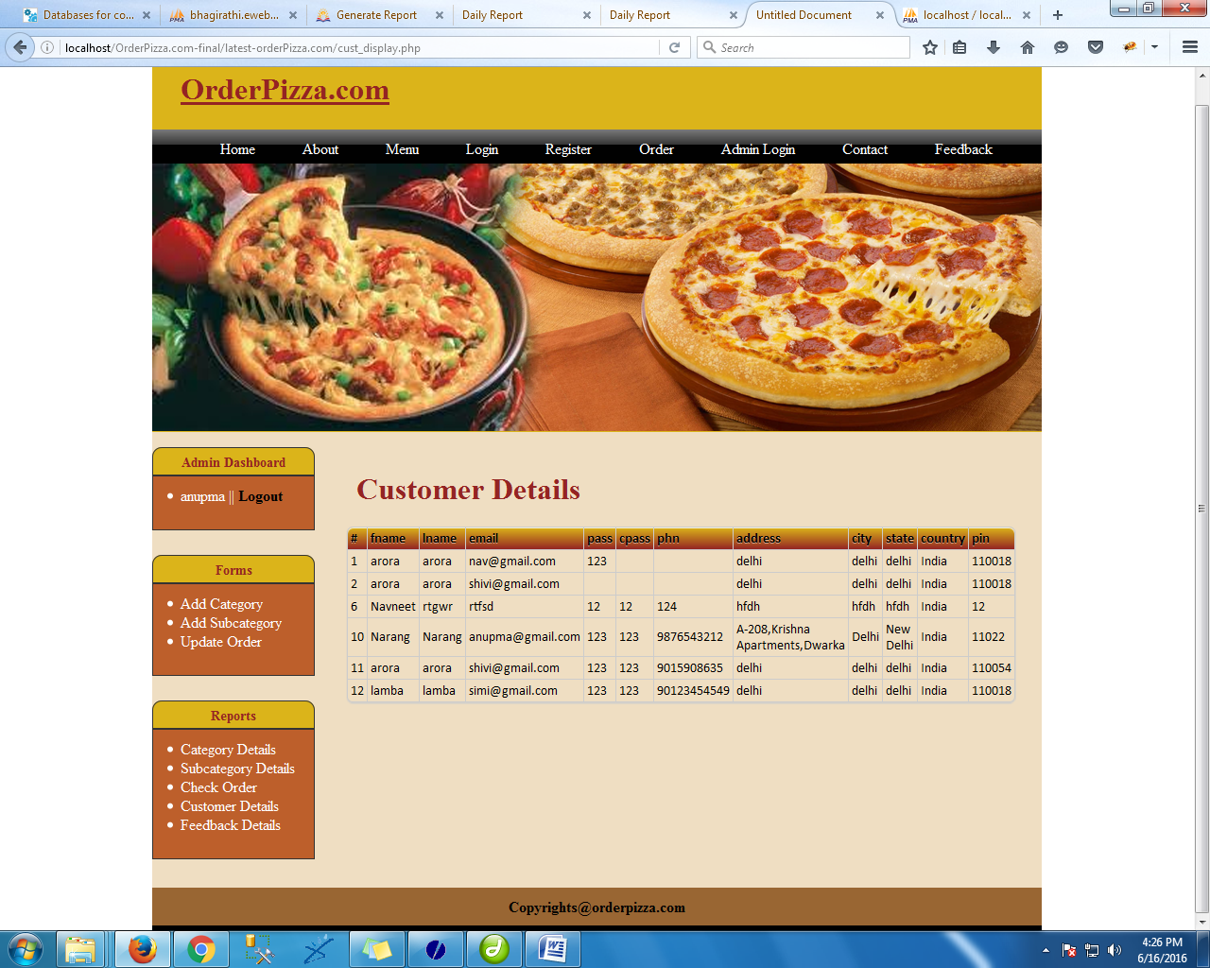

<?php

session_start();

include('adm-lock.php');

?>

<!DOCTYPE html PUBLIC "-//W3C//DTD XHTML 1.0 Transitional//EN" "http://www.w3.org/TR/xhtml1/DTD/xhtml1-transitional.dtd">

<html xmlns="http://www.w3.org/1999/xhtml">

<head>

<meta http-equiv="Content-Type" content="text/html; charset=iso-8859-1" />

<title>Untitled Document</title>

<link href="css/style.css" rel="stylesheet" type="text/css" />

</head>

<body>

<div class="main" >

<?php include('header.php');

?>

<div class="body">

<div class="adminleft">

<?php include('adminleft.php');

?>

</div>

<div class="adminright" style="width:735px">

<br />

<h1 style=" margin-left:10px; margin-right:10px;color:#942423"> Customer Details</h1>

<table class="bordered" style="font-size:14px;width: 90%;">

<thead>

<tr>

<th>#</th>

<th>fname</th>

<th>lname</th>

<th>email</th>

<th>pass</th>

<th>cpass</th>

<th>phn</th>

<th>address</th>

<th>city</th>

<th>state</th>

<th>country</th>

<th>pin</th>

</tr>

</thead>

<?php

$result=mysql_query("SELECT * FROM customer");

while($row=mysql_fetch_array($result))

{

?>

<tr>

<td><?php echo $row['id'];?></td>

<td><?php echo $row['fname'];?> </td>

<td><?php echo $row['lname'];?> </td>

<td><?php echo $row['email'];?> </td>

<td><?php echo $row['pass'];?> </td>

<td><?php echo $row['cpass'];?> </td>

<td><?php echo $row['phn'];?> </td>

<td><?php echo $row['address'];?> </td>

<td><?php echo $row['city'];?> </td>

<td><?php echo $row['state'];?> </td>

<td><?php echo $row['country'];?> </td>

<td><?php echo $row['pin'];?> </td>

</tr>

<?php

}

?>

</table>

</div></div>

<?php include('footer.php');

?>

</div>

</body>

</html>

**feed_welcome.php**

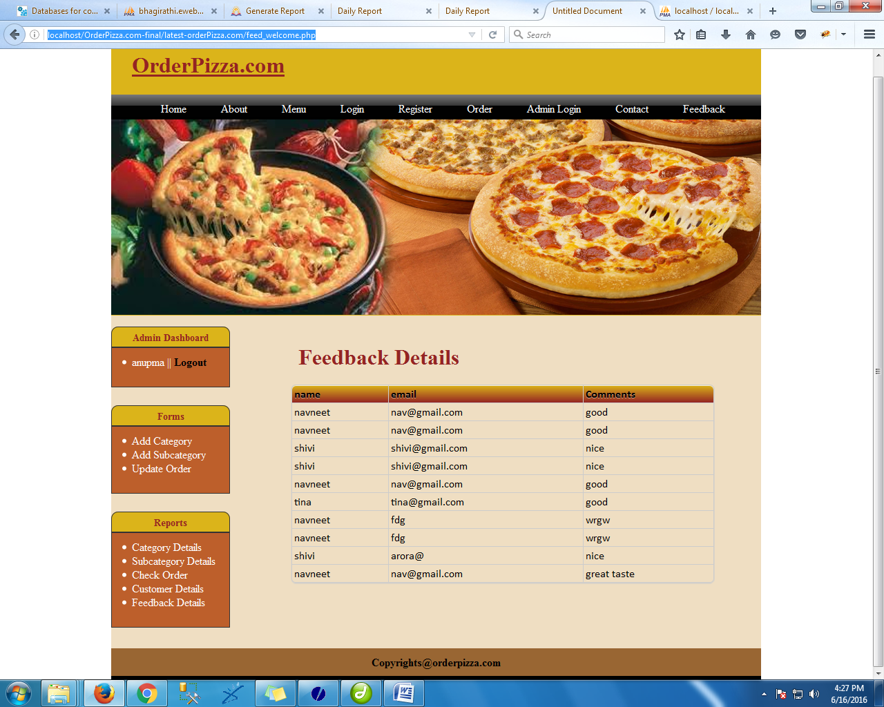

<?php

session_start();

include('adm-lock.php');

?>

<!DOCTYPE html PUBLIC "-//W3C//DTD XHTML 1.0 Transitional//EN" "http://www.w3.org/TR/xhtml1/DTD/xhtml1-transitional.dtd">

<html xmlns="http://www.w3.org/1999/xhtml">

<head>

<meta http-equiv="Content-Type" content="text/html; charset=iso-8859-1" />

<title>Untitled Document</title>

<link href="css/style.css" rel="stylesheet" type="text/css" />

</head>

<body>

<div class="main" >

<?php include('header.php');

?>

<div class="body">

<div class="adminleft">

<?php include('adminleft.php');

?>

</div>

<div class="adminright">

<br />

<h1 style=" margin-left:10px; margin-right:10px;color:#942423">Feedback Details</h1>

<table class="bordered" style="font-size:16px;width: 90%;">

<thead>

<tr>

<th>name</th>

<th>email</th>

<th>Comments</th>

</tr>

</thead>

<?php

$result=mysql_query("SELECT * FROM feedback");

while($row=mysql_fetch_array($result))

{

?>

<tr>

<td><?php echo $row['name'];?> </td>

<td><?php echo $row['email'];?></td>

<td><?php echo $row['comments'];?> </td>

</tr>

<?php

}

?>

</table>

</div></div>

<?php include('footer.php');

?>

</div>

</body>

</html>

**pizzaMore.php**

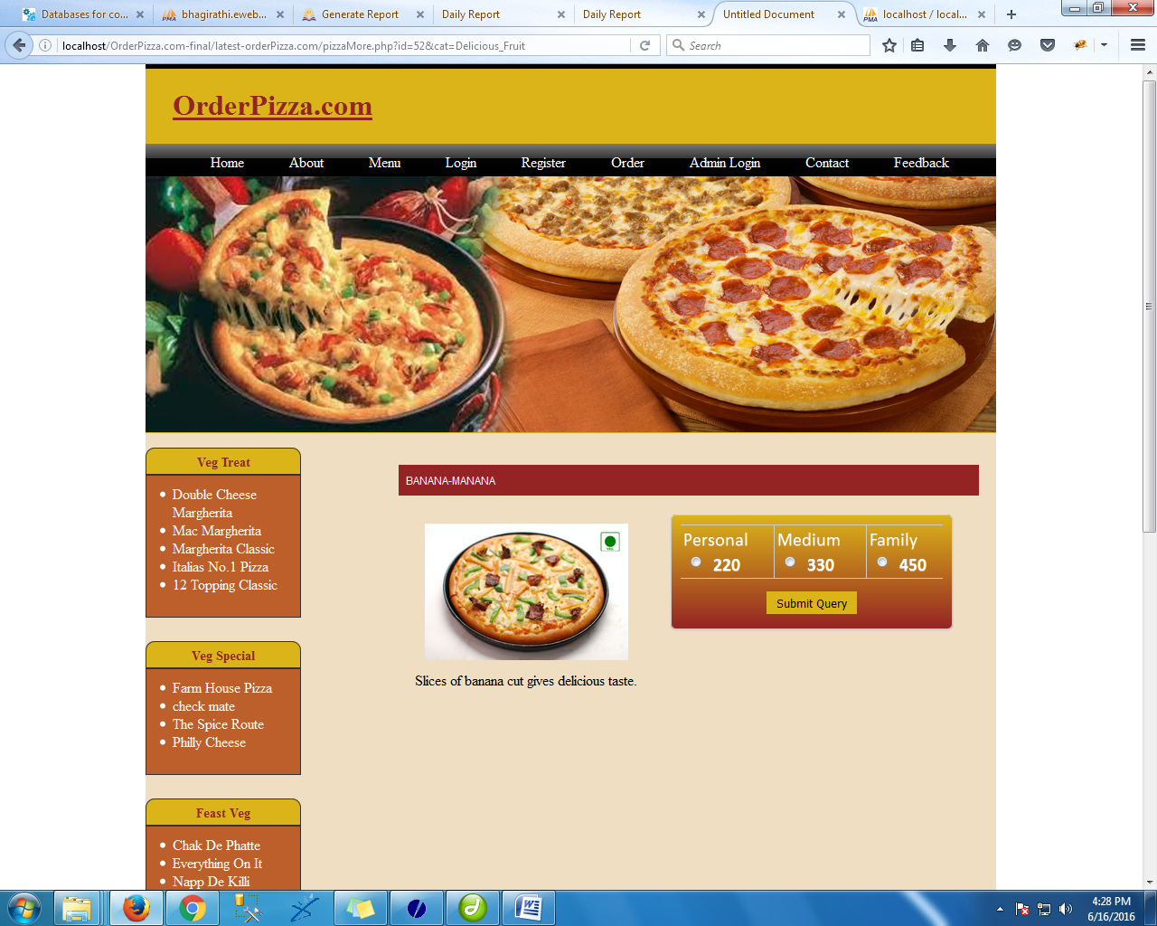

<!DOCTYPE html PUBLIC "-//W3C//DTD XHTML 1.0 Transitional//EN" "http://www.w3.org/TR/xhtml1/DTD/xhtml1-transitional.dtd">

<html xmlns="http://www.w3.org/1999/xhtml">

<head>

<meta http-equiv="Content-Type" content="text/html; charset=iso-8859-1" />

<title>Untitled Document</title>

<link href="css/style.css" rel="stylesheet" type="text/css" />

</head>

<body>

<?php

include('config.php');

session_start();

?>

<div class="main" >

<?php include('header.php');

?>

<div class="body">

<div class="adminleft">

<?php include('left.php'); ?>

</div>

<div class="adminright">

<br />

<?php

$id=$_GET['id'];

$catName=$_GET['cat'];

$scat=mysql_Query("Select * from subcategory where id='$id'");

while($r=mysql_fetch_array($scat))

{

?>

<h4 class="menu-head"><?php echo $r['sname']; ?></h4>

<h1 style=" margin-left:0px; margin-right:10px;color:#942423"></h1>

<div class="boxx" style="background:none">

<IMG src="./<?php echo $r['path']; ?>" width="75%" />

</div>

<div class="Mainboxx bordered">

<form action="<?php if(isset($_SESSION['login_name'])){ echo "order.php"; } else { echo "cust_log.php"; } ?>" method="post">

<input type="hidden" name="sid" value="<?php echo $id; ?>" style="width:20px"/>

<input type="hidden" name="sname" value="<?php echo $r['sname']; ?>" style="width:20px"/>

<table>

<tr>

<td>Personal <input type="radio" name="type" value="Personal-<?php echo $r['personal_price']; ?>" style="width:20px"/>

<strong><?php echo $r['personal_price']; ?></strong></td>

<td>Medium <input type="radio" name="type" value="Medium-<?php echo $r['medium_price']; ?>" style="width:20px" />

<strong><?php echo $r['medium_price']; ?></strong> </td>

<td>Family <input type="radio" name="type" value="Family-<?php echo $r['family_price']; ?>" style="width:20px"/>

<strong><?php echo $r['family_price']; ?></strong> </td>

</tr>

<tr>

<td colspan="3"><br /><center><input class="button" style="background-color:#DBB41A; color:#000000; border:#000000" type="submit"></center></td>

</tr>

</table>

</form>

</div>

<div class="boxx" style="background:none; color:#000000">

<p><?php echo $r['toppings']; ?></p></div>

<?php

}

?>

</div>

</div>

<?php include('footer.php');

?>

</div>

</div>

</body>

</html>

**Order.php**

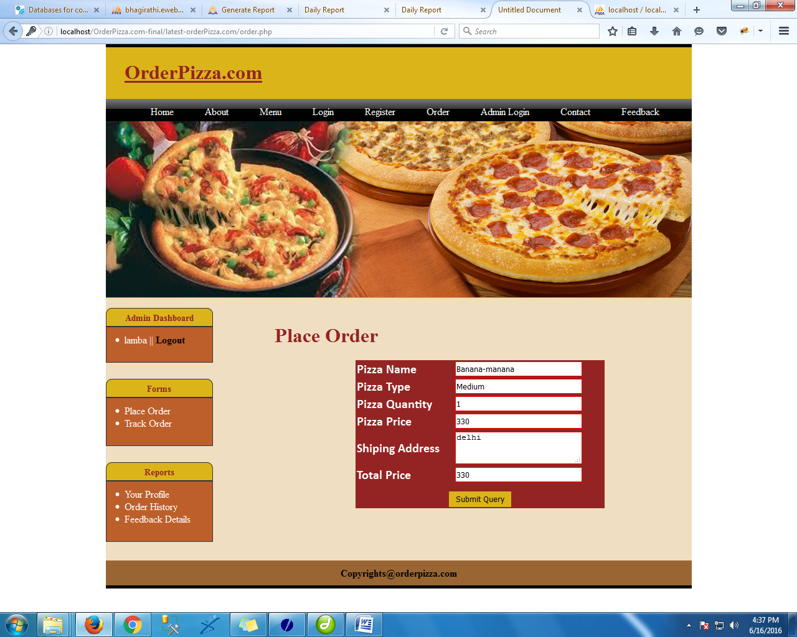

<?php

session_start();

include('lock.php');

?>

<!DOCTYPE html PUBLIC "-//W3C//DTD XHTML 1.0 Transitional//EN" "http://www.w3.org/TR/xhtml1/DTD/xhtml1-transitional.dtd">

<html xmlns="http://www.w3.org/1999/xhtml">

<head>

<meta http-equiv="Content-Type" content="text/html; charset=iso-8859-1" />

<title>Untitled Document</title>

<link href="css/style.css" rel="stylesheet" type="text/css" />

<script>

function calculate()

{

var basic=document.getElementById('basic').value;

var num=document.getElementById('num').value;

if(num=="")

{

num=1;

}

//var amount=document.getElementById('pending').value;

var final=basic*num;

document.getElementById('total').value=final;

//document.getElementById('am').innerHTML="Your Course Fee : " + total + " Rs.";

}

</script>

</head>

<body>

<div class="main" >

<?php include('header.php');

?>

<div class="body">

<div class="adminleft">

<?php include('custLeft.php');

?>

</div>

<div class="adminright">

<br />

<h1 style=" margin-left:10px; margin-right:10px;color:#942423">Place Order</h1>

<?php

$sid=$_POST['sid'];

$price=$_POST['type'];

$pizza=explode("-",$price);

$type=$pizza[0];

$type_price=$pizza[1];

?>

<form action="order_action.php" method="post">

<input type="hidden" name="sid" placeholder="Pizza name" value="<?php echo $sid; ?>">

<table align="center" border="0" bordercolor="black" bgcolor="#942423" width="400" height="150" style="border:thick; border:#000000; color:#FFFFFF;" cellpadding="2" cellspacing="3">

<tr>

<td><b>Pizza Name</b></td>

<td><input type="text" name="sname" placeholder="Pizza name" value="<?php echo $_POST['sname']; ?>"> </td>

</tr>

<tr>

<td><b>Pizza Type</b></td>

<td ><input type="text" name="type" placeholder="Pizza name" value="<?php echo $type; ?>"> </td>

</tr>

<tr>

<td><b>Pizza Quantity</b></td>

<td ><input type="text" name="num" placeholder="Pizza name" id="num" value="1" onkeyup="calculate();"> </td>

</tr>

<tr>

<td><b>Pizza Price</b></td>

<td ><input type="text" name="basic" placeholder="Pizza name" id="basic" value="<?php echo $type_price; ?>" readonly="readonly"> </td>

</tr>

<tr>

<td><b>Shiping Address</b></td>

<td ><textarea name="del_address" ><?php echo $_SESSION['login_addr']; ?></textarea> </td>

</tr>

<tr>

<td><b>Total Price</b></td>

<td ><input type="text" name="total" placeholder="Pizza name" id="total" value="<?php echo $type_price; ?>" readonly="readonly"> </td>

</tr>

<tr>

<td colspan="2" align="center"><br /><input type="submit" class="button" style="background-color:#DBB41A; color:#000000; border:#000000"/></td>

</tr>

</table><br />

<br />

</form>

</div></div>

<?php include('footer.php');

?>

</div>

</body>

</html>

**Thankyou.php**

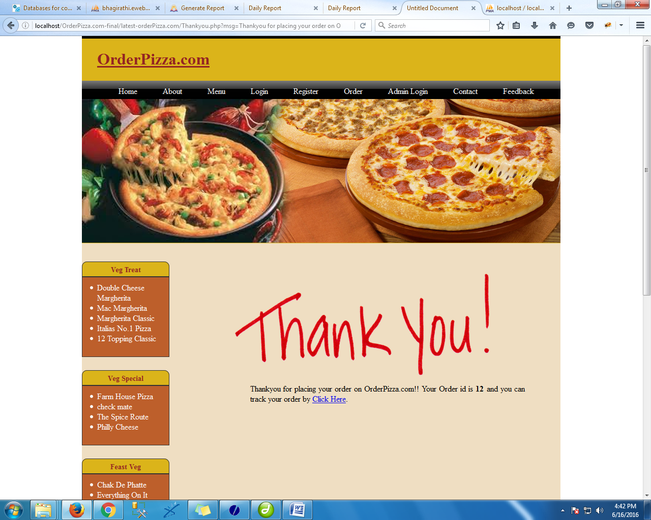

<!DOCTYPE html PUBLIC "-//W3C//DTD XHTML 1.0 Transitional//EN" "http://www.w3.org/TR/xhtml1/DTD/xhtml1-transitional.dtd">

<html xmlns="http://www.w3.org/1999/xhtml">

<head>

<meta http-equiv="Content-Type" content="text/html; charset=iso-8859-1" />

<title>Untitled Document</title>

<link href="css/style.css" rel="stylesheet" type="text/css" />

</head>

<body>

<div class="main" >

<?php include('header.php');

?>

<div class="body">

<br />

<div class="adminleft">

<?php include('left.php'); ?>

</div>

<div class="adminright" align="center" >

<br />

<img src="pizza/thankyou.png" width="500" height="200" style="margin-right:100px; margin-top:20px"/>

<p style="text-align: justify; margin-left:70px; margin-right:70px"><?php echo $_GET['msg']; ?></p>

</div></div>

<?php include('footer.php');

?>

</div>

</body>

</html>

**track_order.php**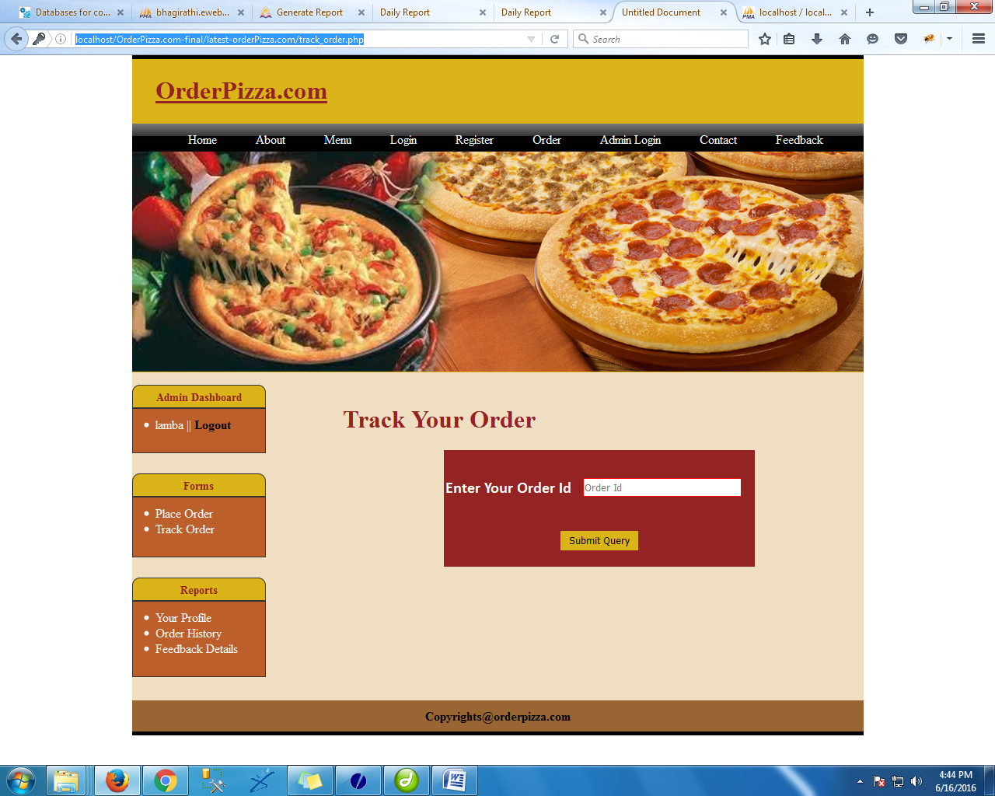

<?php

session_start();

include('lock.php');

?>

<!DOCTYPE html PUBLIC "-//W3C//DTD XHTML 1.0 Transitional//EN" "http://www.w3.org/TR/xhtml1/DTD/xhtml1-transitional.dtd">

<html xmlns="http://www.w3.org/1999/xhtml">

<head>

<meta http-equiv="Content-Type" content="text/html; charset=iso-8859-1" />

<title>Untitled Document</title>

<link href="css/style.css" rel="stylesheet" type="text/css" />

<script>

function calculate()

{

var basic=document.getElementById('basic').value;

var num=document.getElementById('num').value;

if(num=="")

{

num=1;

}

//var amount=document.getElementById('pending').value;

var final=basic*num;

document.getElementById('total').value=final;

//document.getElementById('am').innerHTML="Your Course Fee : " + total + " Rs.";

}

</script>

</head>

<body>

<div class="main" >

<?php include('header.php');

?>

<div class="body">

<div class="adminleft">

<?php include('custLeft.php');

?>

</div>

<div class="adminright">

<br />

<h1 style=" margin-left:10px; margin-right:10px;color:#942423">Track Your Order</h1>

<form action="track_action.php" method="post">

<table align="center" border="0" bordercolor="black" bgcolor="#942423" width="400" height="150" style="border:thick; border:#000000; color:#FFFFFF;" cellpadding="2" cellspacing="3">

<tr>

<td><b>Enter Your Order Id</b></td>

<td><input type="text" name="oid" placeholder="Order Id" value=""> </td>

</tr>

<tr>

<td colspan="2" align="center"><input type="submit" class="button" style="background-color:#DBB41A; color:#000000; border:#000000"/></td>

</tr>

</table><br />

<br />

</form>

</div></div>

<?php include('footer.php');

?>

</div>

</body>

</html>

**12. PROCESS INVOLVED**

**MODULES**

Number of modules and their description to provide an estimation of the student’s effort on the project.

**Login/Sign Up**

When a customer visits the online pizza ordering system of any pizzeria, he will be asked to login or sign up with them for better experience. The customer has to create a unique username and a password.Then he /she need to enter details like Name, phone number, address. After these steps account of that customer will be created.

**Menu**  
The system will provide customers a menu in which all the pizzas and non pizza items will be shown with their prices. The pizzas in the menu are created by the professional chefs of the pizzeria.  
The ingredients in this pizza can be changed according to the customer interests. The customer can select any pizza from the menu or build custom pizza. Each pizza will be shown with their image and price. The ingredients used in the making of that pizza can also be seen. Each of these ingredients can be removed or other new ingredients can be added in the order. After each selection or de-selection, the grand total of the order will be updated.

**Ordering**

The first use case is ordering. To order, a potential customer must first know what he can choose from (“What’s on the menu?”). For ordering custom pizzas a customer

will have to know the ingredients he can choose from and how choosing ingredients ill influence the total price. Customers pick ingredients for their pizza and sometimes they want a double portion of specific ingredients. When a customer is choosing his pizza, he may want to order several pizzas of the same configuration. A customer may also want to order non-pizza side orders, such as drinks and salads. Also the customer will have to provide his name, address and telephone number. A customer can also pick another delivery date and time if they wish for the order to be delivered on a later date and time. Customers can order up to two weeks in advance.

**Order processing**

When an order has been confirmed by a customer order processing begins.

Throughout the order processing the order status will be updated and the customer will be notified. New orders will show up in a list for the employees in the kitchen. They need to state which products are ordered and which ingredients are chosen for the custom pizzas. The kitchen employees have to look at the order and decide if they can prepare the order or not. When the decision is made, the order status will change and the customer will be notified. After preparing the order the order status will be updated and the delivery employees will take over. They will look up the name and address, and deliver the order. The customer will also be notified when the order is prepared and ready to be delivered. When delivery has been completed or failed, the order status will be changed once more.

**Administration**

Custom pizzas are made by selecting several ingredients, the list of available Ingredients and their prices are administrated by an employee, for instance the manager. Administration includes added, editing and deleting ingredients. Besides the administration of ingredients, the non-pizza side orders must also be administrated. Administrators also need to have logs of previous orders. The tasks which can be performed by the admin are:

* 1. He can add/edit/delete different ingredients into the system. He can add/edit/delete new pizzas, their images, prices and other details. The same functions can be performed for non pizza items.
  2. He can add/edit/delete users in this system. It’s the admin who add new employees account into the system.

Admin has rights to add/edit/delete orders for customers.

**Security**

Data have to very secure and reliable in every manner, must have covered with user id and password, which are only allowed to staff, every staff have their unique id with password.

**Delivery**

Home Delivery database maintenance, client’s customer details, delivery status, delivery address, balance, staff for delivery.

**Track your Order**

This is another interesting feature which helps customers to keep a track of his order. The customer is notified at every step of their order completion. After making payment the customer is shown the time by which his order will be delivered to his doorstep

User

p_code

P_id

request

no

Yes

No

o

Yes

Product

**Flowchart**

User

p_code p_id

Format checking

Match in D.B.

Display

error

end

Insert information

in table

no

Yes

Yes

No

* 1. **Making_New_USER**:

In this module new user is created. There are two category of users. One is Admin group users and the second is General user. General user has only privilege to insert data and Admin group has privilege to make any modification.

New user can added by the Administrator.

The Process Logic to be followed in this module is as follows:-

[LOG-IN]

//User log in by passing user id and password.

Id 🡨 [User id]

Pass 🡨 [Password]

[CHECK PRIVILEGE]

if (id == “Admin”) then

//check in Admin table

//db= table at database

if (id = db.id and pass = db.pass)

//Open Admin page

Else

//Check in User page

//db= table at database

if (id = db.id and pass = db.pass)

//Open User page

else

Print “Error”

[ADMIN:?]

//Admin chooses Insert User option

[NEW USER FORM]

// New user form is opened

[SUBMIT]

// Format check is done

if (format not correct)

Print “Error”

Else

//Value is inserted.

**DFD**

USER

Id, pass

branch

request

no

yes

no

yes

Login

**Flowchart**

user

Id ,pass & branch

Format checking

Match in D.B.

Display

error

end

Insert

information

in table

No

Yes

Yes

No

* 1. **UPDATE BRANCH :**

The Process Logic to be followed in this module is as follows:-

[LOG-IN]

//User log in by passing user id and password.

Id 🡨 [User id]

Pass 🡨 [Password]

[CHECK PRIVILEGE]

if (id == “Admin”) then

//check in Admin table

//db= table at database

if (id = db.id and pass = db.pass)

//Open Admin page

Else

//Check in User page

//db= table at database

if (id = db.id and pass = db.pass)

//Open User page

else

Print “Error”

[ADMIN:?]

//Admin chooses Update Branch option

[BRANCH FORM]

// Branch form is opened

//take branch name

//retrieve branch info and open new form

[BRANCH INFO FORM IN EDIT MODE]

//Make appropriate changes

[SUBMIT]

// Format check is done

if (format not correct)

Print “Error”

Else

//Value is updated

**DFD**

Admin

B_code

B_id

request

no

Yes

Yes

o

No

Branch

**Flowchart**

Admin

B_code b_id

Format checking

Check

in D.B.

Display

error

end

Update

information

in table

no

Yes

No

Yes

**3. Removing BRANCH:**

In this module the system provide facility to the administrator to remove branch which is not required. The Process Logic to be followed in this module is as follows:-

[LOG-IN]

//User log in by passing user id and password.

Id 🡨 [User id]

Pass 🡨 [Password]

[CHECK PRIVILEGE]

if (id == “Admin”) then

//check in Admin table

//db= table at database

if (id = db.id and pass = db.pass)

//Open Admin page

Else

//Check in User page

//db= table at database

if (id = db.id and pass = db.pass)

//Open User page

else

Print “Error”

[ADMIN:?]

//Admin chooses Delete Branch option

[DELTE BRANCH FORM]

// Delete Branch form is opened

//take branch name

//retrieve branch info and open new form

[ASK FOR DELETING THIS BRANCH]

//If user select yes then

[SUBMIT]

//Value is deleted at the database level

**DFD**

Admin

B_code

B_id

request

no

Yes

Yes

o

No

Branch

**Flowchart**

Admin

B_code b_id

Format checking

Match in D.B.

Display

error

end

Delete

information

in table

no

Yes

No

Yes

**4. Removing PRODUCT Info:**

The Process Logic to be followed in this module is as follows:-

[LOG-IN]

//User log in by passing user id and password.

Id 🡨 [User id]

Pass 🡨 [Password]

[CHECK PRIVILEGE]

if (id == “Admin”) then

//check in Admin table

//db= table at database

if (id = db.id and pass = db.pass)

//Open Admin page

Else

//Check in User page

//db= table at database

if (id = db.id and pass = db.pass)

//Open User page

else

Print “Error”

[ADMIN:?]

//Admin chooses Delete Product info option

[DELTE PRODUCT FORM]

// Delete Product form is opened

//take product name

//retrieve product info and open new form

[ASK FOR DELETING THIS PRODUCT]

//If user select yes then

[SUBMIT]

//Value is deleted at the database level

**DFD**

User

p_code

P_id

request

no

Yes

Yes

o

No

Product

**Flowchart**

User

p_code p_id

Format checking

Match in D.B.

Display

error

end

Delete information

from table

no

Yes

No

Yes

**5. DELETE USER INFORMATION**

The Process Logic to be followed in this module is as follows:-

1. Enter user id, password &branch.
2. Then request for format checking that anything is missing or not
3. If missing then display **error** msg.
4. If format checking is correct then check information in **login** table in database.
5. If information not matches in login table then then display there is no such type of user.
6. If information matches in **login** table then deletion process will go on.

**DFD**

USER

Id, pass

branch

request

no

yes

yes

no

Login

**Flowchart**

user

Id ,pass & branch

Format checking

Match in D.B.

Display

error

end

Delete

information

in table

no

yes

no

yes

* 1. **INSERT BRANCH**

The Process Logic to be followed in this module is as follows:-

1. Admin enter b_code, b_id for insertion new branch.
2. Then request for format checking that anything is missing or not.
3. If missing then display **error** msg.
4. If format checking is correct then check information in **branch** table in database.
5. If information match in branch table then display information all ready exits.
6. If information not matches in **branch** table then insertion process will go on.

**DFD**

Admin

B_code

B_id

request

no

yes

no

yes

Branch

**Flowchart**

Admin

B_code b_id

Format checking

Match in D.B.

Display

error

end

Insert

information

in table

no

Yes

Yes

No

* **UPDATE PRODUCT**

The Process Logic to be followed in this module is as follows:-

1. Users enter p_code, p_id for updating product.
2. Then request for format checking that anything is missing or not.
3. If missing then display **error** msg.
4. If format checking is correct then check information in **product** table in database.
5. If information not match in product table then display information doesnot exists.
6. If information match in **product** table then updating process will go on.

**DFD**

User

p_code

P_id

request

no

Yes

Yes

o

No

Product

**Flowchart**

User

p_code p_id

Format checking

Match in D.B.

Display

error

end

Update information

in table

no

Yes

No

Yes

**DATA TABLE**

**Admin Table: To store users details and authentications provided to them.**

|  |  |  |  |
| --- | --- | --- | --- |
| **Fields** | **Type** | **Constraint** | **Description** |
| **ID** | int(11) | Primary Key | ID |
| **Username** | Varch(100) | Not Null | Username |
| **Password** | Varch(100) | Not Null | Password |

**Customer Details: To store Customer Details.**

|  |  |  |  |
| --- | --- | --- | --- |
| **Fields** | **Type** | **Constraint** | **Description** |
| **ID** | Int(1) | Primary Key | ID |
| **First name** | Varch(20) | Not Null | First name |
| **Last name** | Varch(100) | Not Null | Last name |
| **Email** | Varch(100) | Not Null | Email |
| **Pass** | Varch(100) | Not Null | Pass |
| **Phn** | Varch(100) | Not Null | Phn |
| **Address** | Varch(100) | Not Null | Address |
| **City** | Varch(100) | Not Null | City |
| **State** | Varch(100) | Not Null | State |
| **Country** | Varch(100) | Not Null | Country |
| **Pin** | Varch(100) | Not Null | Pin |

**Feedback Table: To store details of the products delivered.**

|  |  |  |  |
| --- | --- | --- | --- |
| **Fields** | **Type** | **Constraint** | **Description** |
| **Nmae** | Varch(100) | Not Null | Nmae |
| **Email** | Varch(100) | Not Null | Email |
| **Comments** | Varch(100) | Not Null | Comments |

**Category Table: To store details of the products delivered.**

|  |  |  |  |
| --- | --- | --- | --- |
| **Fields** | **Type** | **Constraint** | **Description** |
| **Category ID** | int | Primary Key | Category ID |
| **Category name** | Varch(50) | Not Null | Category name |

**Order Table: To store details of the orders placed.**

|  |  |  |  |
| --- | --- | --- | --- |
| Fields | Type | Constraint | Description |
| Id | int11) | Primary Key | Id |
| User Id | Varch(20) | Not Null | User id |
| User name | Varch(20) | Not Null | User name |
| Address | Varch(40) | Not Null | Address |
| Type | Varch(30) | Not Null | Type |
| Basic | Varch(100) | Not Null | Basic |
| Num | Varch(100) | Not Null | Num |
| Price | Varch(40) | Not Null | Price |
| Status | Varch(100) | Not Null | Status |

**Subcategory Details: To store supplier details.**

|  |  |  |  |
| --- | --- | --- | --- |
| **Fields** | **Type** | **Constraint** | **Description** |
| **Cid** | Varch(100) | Not Null | Category id |
| **Name** | Varch(100) | Not Null | name |
| **Personal price** | Varch(100) | Not Null | Personal price |
| **Medium price** | Varch(100) | Not Null | Medium price |
| **Family** | Varch(100) | Not Null | Family |
| **Toppings** | Varch(100) | Not Null | Toppings |
| **Img** | Varch(100) | Not Null | Img |
| **Path** | Varch(150) | Not Null | Path |

**13. METHODOLOGY USED FOR TESTING**

**TESTING PHASES**

Software Testing is an [empirical](http://en.wikipedia.org/wiki/Empirical) investigation conducted to provide stakeholders with information about the quality of the product or service under test, with respect to the context in which it is intended to operate. This includes, but is not limited to, the process of executing a program or application with the intent of finding [software bugs](http://en.wikipedia.org/wiki/Software_bugs). It can also be stated as the process of validating and verifying that a software program/application/product meets the business and technical requirements that guided its design and development, so that it works as expected and can be implemented with the same characteristics.

A primary purpose for testing is to detect software failures so that defects may be uncovered and corrected. This is a non-trivial pursuit. Testing cannot establish that a product functions properly under all conditions but can only establish that it does not function properly under specific conditions.[[11]](http://en.wikipedia.org/wiki/Software_testing#cite_note-Kaner1-10#cite_note-Kaner1-10) The scope of software testing often includes examination of code as well as execution of that code in various environments and conditions as well as examining the aspects of code: does it do what it is supposed to do and do what it needs to do. In the current culture of software development, a testing organization may be separate from the development team. There are various roles for testing team members. Information derived from software testing may be used to correct the process by which software is developed.

### Defects and failures

Not all software defects are caused by coding errors. One common source of expensive defects is caused by requirements gaps, e.g., unrecognized requirements, that result in errors of omission by the program designer. A common source of requirements gaps is [non-functional requirements](http://en.wikipedia.org/wiki/Non-functional_requirements) such as [testability](http://en.wikipedia.org/wiki/Testability), [scalability](http://en.wikipedia.org/wiki/Scalability), [maintainability](http://en.wikipedia.org/wiki/Maintainability), [usability](http://en.wikipedia.org/wiki/Usability), [performance](http://en.wikipedia.org/wiki/Computer_performance), and [security](http://en.wikipedia.org/wiki/Computer_security).

Software faults occur through the following process. A programmer makes an [error](http://en.wikipedia.org/wiki/Human_error) (mistake), which results in a [defect](http://en.wikipedia.org/wiki/Fault_(technology)) (fault, bug) in the software [source code](http://en.wikipedia.org/wiki/Source_code). If this defect is executed, in certain situations the system will produce wrong results, causing a [failure](http://en.wikipedia.org/wiki/Failure).[[12]](http://en.wikipedia.org/wiki/Software_testing#cite_note-ctfl-11#cite_note-ctfl-11) Not all defects will necessarily result in failures. For example, defects in [dead code](http://en.wikipedia.org/wiki/Dead_code) will never result in failures. A defect can turn into a failure when the environment is changed. Examples of these changes in environment include the software being run on a new [hardware](http://en.wikipedia.org/wiki/Hardware) platform, alterations in [source data](http://en.wikipedia.org/wiki/Source_data) or interacting with different software.[[12]](http://en.wikipedia.org/wiki/Software_testing#cite_note-ctfl-11#cite_note-ctfl-11) A single defect may result in a wide range of failure symptoms.

### Compatibility

A frequent cause of software failure is [compatibility](http://en.wikipedia.org/wiki/Computer_compatibility) with another application, a new [operating system](http://en.wikipedia.org/wiki/Operating_system), or, increasingly, [web browser](http://en.wikipedia.org/wiki/Web_browser) version. In the case of lack of [backward compatibility](http://en.wikipedia.org/wiki/Backward_compatibility), this can occur (for example...) because the programmers have only considered coding their programs for, or testing the software upon, "the *latest* version of" this-or-that operating system. The unintended consequence of this fact is that: their latest work might not be fully compatible with earlier mixtures of software/hardware, or it might not be fully compatible with *another* important operating system. In any case, these differences, whatever they might be, may have resulted in (unintended...) software failures, as witnessed by some significant population of computer users.

This could be considered a "prevention oriented strategy" that fits well with the latest testing phase suggested by [Dave Gelperin](http://en.wikipedia.org/wiki/Dave_Gelperin) and [William C. Hetzel](http://en.wikipedia.org/wiki/William_C._Hetzel), as cited below [[13]](http://en.wikipedia.org/wiki/Software_testing#cite_note-12#cite_note-12).

### Input combinations and preconditions

A very fundamental problem with software testing is that testing under *all* combinations of inputs and preconditions (initial state) is not feasible, even with a simple product. This means that the number of [defects](http://en.wikipedia.org/wiki/Software_bug) in a software product can be very large and defects that occur infrequently are difficult to find in testing. More significantly, [non-functional](http://en.wikipedia.org/wiki/Non-functional_requirements) dimensions of quality (how it is supposed to *be* versus what it is supposed to *do*) -- for example, usability, [scalability](http://en.wikipedia.org/wiki/Scalability), [performance](http://en.wikipedia.org/wiki/Computer_performance), [compatibility](http://en.wikipedia.org/wiki/Backward_compatibility), reliability -- can be highly subjective; something that constitutes sufficient value to one person may be intolerable to another.

### Static vs. dynamic testing

There are many approaches to software testing. [Reviews](http://en.wikipedia.org/wiki/Code_review), [walkthroughs](http://en.wikipedia.org/wiki/Software_walkthrough) or [inspections](http://en.wikipedia.org/wiki/Software_inspection) are considered as [static testing](http://en.wikipedia.org/wiki/Static_testing), whereas actually executing programmed code with a given set of [test cases](http://en.wikipedia.org/wiki/Test_case) is referred to as [dynamic testing](http://en.wikipedia.org/wiki/Dynamic_testing). The former can be, (and unfortunately in practice often is...) omitted, whereas the latter takes place when programs begin to be used for the first time - which is normally considered the beginning of the testing stage. This may actually begin before the program is 100% complete in order to test particular sections of code (modules or discrete functions). For example, [Spreadsheet](http://en.wikipedia.org/wiki/Spreadsheet) programs are, by their very nature, tested to a large extent "[on the fly](http://en.wikipedia.org/wiki/On_the_fly)" during the build process as the result of some calculation or text manipulation is shown interactively immediately after each formula is entered

**1. UNIT TESTING:**

This is the smallest testable unit of a computer system and is normally tested using the white box testing. The author of the programs usually carries out unit tests.

**2. INTEGRATION TESTING:**

In integration testing, the different units of the system are integrated together to form the complete system and this type of testing checks the system as whole to ensure that it is doing what is supposed to do. The testing of an integrated system can be carried out top-down, bottom-up, or big-bang. In this type of testing, some parts will be tested with white box testing and some with black box testing techniques. This type of testing plays very important role in increasing the systems productivity. We have checked our system by using the integration testing techniques.

**3. SYSTEM TESTING:**

A part from testing the system to validate the functionality of software against the requirements, it is also necessary to test the non-functional aspect of the system. Some examples of non-functional tools include tests to check performance, data security, usability/user friendliness, volume, load/stress that we have used in our project to test the various modules.

**System testing consists of the following steps:**

1. Program(s) testing.

2. String testing.

3. System testing.

4. System documentation.

5. User acceptance testing.

**4. FIELD TESTING:**

This is a special type of testing that may be very important in some projects. Here the system is tested in the actual operational surroundings. The interfaces with other systems and the real world are checked. This type of testing is very rarely used. So far our project is concerned; we haven't tested our project using the field testing.

**5. ACCEPTANCE TESTING:**

After the developer has completed all rounds of testing and he is satisfied with the system, then the user takes over and re-tests the system from his point of view to judge whether it is acceptable according to some previously identified criteria. This is almost always a tricky situation in the project because of the inherent conflict between the developer and the user. In this project, it is the job of the bookstores to check the system that whether the made system fulfills the goals or not.

**WHY SYSTEM TESTING?**

Testing is vital to the success of the system. System testing makes a logical assumption that if all the parts of the system are correct, the goal will be successfully achieved. Inadequate testing results in two types of problems:

1. The time lag between the cause and the appearance of the problem.

2. The effect of system errors on the files and records within the system.

**14. TEST REPORT, PRINTOUT OF THE REPORTS, PRINTOUT OF THE CODE SHEET**

**ACTIVITY NETWORK FOR SYSTEM TESTING**

**The test plan entails the following activities:**

1. Prepare test plan.

2. Specify conditions for user acceptance testing.

3. Prepare test data for program testing.

4. Prepare test data for transaction path testing.

5. Plan user training.

6. Compile/assemble programs.

7. Prepare job performance aids.

8. Prepare operational documents.

**PREPARE TEST :** A workable test plan must be prepared in accordance with established design specifications. It includes the following items:

* Outputs expected from the system.
* Criteria for evaluating outputs.
* A volume of test data.
* Procedure for using test data.
* Personnel and training requirements.

**SPECIFY CONDITIONS FOR USER ACCEPTANCE TESTING**

Planning for user acceptance testing calls for the analyst and the user to agree on conditions for the test.

**PREPARE TEST DATA FOR PROGRAM TESTING**

As each program is coded, test data are prepared and documented to ensure that all aspects of the program are properly tested.

**PREPARE TEST DATA FOR TRANSACTION PATH TESTING**

This activity develops the data required for testing every condition and transactions to be introduced into the system. The path of each transaction from origin to destination is carefully tested reliable results.

**PLAN USER TRAINING**

User training is designed to prepare the user for testing and converting the system. User involvement and training take place parallel with programming for three reasons:

• The system group has time available to spend on training while the programs are being written.

• Initiating a user-training program gives the systems group a clearer image of the user's interest in the new system.

• A trained user participates more effectively in system testing.

The training plan is followed by preparation of the user training manual and other text materials.

**COMPILE / ASSEMBLE PROGRAMS**

All programs have to be compiled / assembled for testing.

**PREPARE JOB PERFORMANCE AIDS**

In this activity the materials to be used by personnel to run the system are specified and scheduled. This includes a display of materials.

**PREPARE OPERATIONAL DOCUMENTS**

During the test plan stage, all operational documents are finalized including copies of the operational formats required by the candidate system.

**SYSTEMS TESTING**

The computer department to ensure that the system functions as specified does this testing. This testing is important to ensure that a working system is handed over to the user for acceptance testing.

**ACCEPTANCE TESTING**

The user to ensure that the system functions, as the user actually wanted performs this testing. With prototyping techniques, this stage becomes very much a formality to check the accuracy and completeness of processing. The screen layouts and output should already have been tested during the prototyping phase.

An error in the program code can remain undetected indefinitely. To prevent this from happening the code was tested at various levels. To successfully test a system, each condition, and combinations of conditions had to be tested. Each program was tested and linked to other programs. This unit of program is tested and linked to other units and so on until the complete system has been tested.

The purpose of testing is to ensure that each program is fully tested. To do so a test plan had to be created. The test plan consists of a number of test runs such as the valid paths through the code, and the exception and error handling paths. For each test run there is a list of conditions tested, the test data used and the result expected. The test plan was then reviewed to check that each path through the code is tested correctly. It is the responsibility of the programmer to collect the data that will produce the required test condition.

**TEST CASES**

|  |  |  |  |  |  |
| --- | --- | --- | --- | --- | --- |
|  |  | **TEST DATA Specifications for ONLINE PIZZA ORDER BOOKING SYSTEM user form1** |  | |  |
|  | **Test Date** | 27-10-2019 | **Programmer name:** | | **ONLINE PIZZA ORDER BOOKING SYSTEM** |
|  | **Tested By:** |  | **Project ID:** | | 11105454 |
|  |  |  |  | |  |
|  |  |  |  | |  |
|  | **Name** | Name | | | the fields are required.Can enter only letters, spaces, hyphens, and apostrophes. No numeric & special characters are allowed( Length upto 32 characters) |
|  | **Address** |  |  | | Will accept only letters, numbers, underscores, and one dot (.) |
|  |  |  |  | |  |
|  | **Password** |  | password length > than 6 alphanumeric | | Don't use your Name or ID |
|  |  |  |  | |  |
|  | **Confirm Pasword** |  | password length > than 6 alphanumeric | | |
|  |  |  |  |  | |
|  | **Email** |  | the fields are required, invalid email id |  | |
|  |  |  |  |  | |

|  |  |  |  |  |  |  |
| --- | --- | --- | --- | --- | --- | --- |
| **Positive Test cases for registration form** | | | | | | |
| **T.C ID** | **PRE-CONDITION** | **T.C DESCRIPTION** | **T.C DATA** | **EXPECTED** | **ACTUAL** | **RESULT** |
| 1 | User should be on https://**ONLINE PIZZA ORDER BOOKING SYSTEM** /registration? And is on Name Field | Check the functionality of Name field | Akhila | Will accept only letters, spaces, hyphens, and apostrophes.Length upto 32 characters. name are required. | Ok | Pass |
| 2 | User should be on https://**ONLINE PIZZA ORDER BOOKING SYSTEM** /registration? And is on Name Field | Check the functionality of Name field | A S | Will accept only letters, spaces, hyphens, and apostrophes.Length upto 32 characters. name are required. | Ok | Pass |
| 3 | User should be on https://**ONLINE PIZZA ORDER BOOKING SYSTEM** /registration? And is on Name Field | Check the functionality of Name field | A Satish | Will accept only letters, spaces, hyphens, and apostrophes.Length upto 32 characters. name are required. | Ok | Pass |
| 4 | User should be on https://**ONLINE PIZZA ORDER BOOKING SYSTEM** /registration? And is on Name Field | Check the functionality of Name field | Akhila S | Will accept only letters, spaces, hyphens, and apostrophes.Length upto 32 characters.name are required. | Ok | Pass |
| 5 | User should be on https://**ONLINE PIZZA ORDER BOOKING SYSTEM** /registration?And is on Name Field | Check the functionality of Employee Name field | pooja Sharma | Will accept only letters, spaces, hyphens, and apostrophes.Length upto 32 characters.name are required. | Ok | Pass |
|  |  |  |  |  |  |  |
| 6 | User should be on https://**ONLINE PIZZA ORDER BOOKING SYSTEM** /registration?And is on Address Field | Check the functionality of Address option | uttam nagar | Will accept only letters, spaces, hyphens, and apostrophes.Length upto 132 characters. name are required. | Ok | Pass |
| 7 | User should be on https://**ONLINE PIZZA ORDER BOOKING SYSTEM** /registration? And is on Address Field | Check the functionality of Address option | Female | Will accept one.This is required | Ok | Pass |
|  |  |  |  |  |  |  |
| 8 | User should be on https://**ONLINE PIZZA ORDER BOOKING SYSTEM** /registration? And is on Address Field | Check the functionality of Address of sign up option | m-10/20 vikashpuri | Will accept only letters, spaces, hyphens, and apostrophes.Length upto 132 characters. name are required. | Ok | Pass |
|  |  |  |  |  |  |  |
|  |  |  |  |  |  |  |
| 18 | User should be on https://**ONLINE PIZZA ORDER BOOKING SYSTEM** /registration? And is on Password Field | Check the functionality of password text box | Avhjklhm | Will accept 6 to 32 characters.Capitalisation matters. and don't use your name ID. | Ok | Pass |
| 19 | User should be on https://**ONLINE PIZZA ORDER BOOKING SYSTEM** /registration? And is on Password Field | Check the functionality of password text box | 654321 | Will accept 6 to 32 characters.Capitalisation matters. and don't use your name or ID. | Ok | Pass |
| 20 | User should be on https://**ONLINE PIZZA ORDER BOOKING SYSTEM** /registration?And is on Password Field | Check the functionality of password text box | 2207** | Will accept 6 to 32 characters.Capitalisation matters. and don't use your name or ID. | Ok | Pass |
| 21 | User should be on https://**ONLINE PIZZA ORDER BOOKING SYSTEM** /registration? And is on Password Field | Check the functionality of password text box | Chinnu1312** | Will accept 6 to 32 characters.Capitalisation matters. and don't use your name or ID. | Ok | Pass |
|  |  |  |  |  |  |  |
| 22 | User should be on https://**ONLINE PIZZA ORDER BOOKING SYSTEM** /registration?And is on Retype Password field | Check the functionality of Retype password text box | Same as the password | Will accept the same password as above. | Ok | Pass |
|  |  |  |  |  |  |  |
| 23 | User should be on https://**ONLINE PIZZA ORDER BOOKING SYSTEM** /registration?And is on Email Field | Check the functionality of Alternate Email text box | akhila.hunagund@gmail.com | Will accept any valid email id or blank | Ok | Pass |
| 24 | User should be on https://**ONLINE PIZZA ORDER BOOKING SYSTEM** /registration? And is on Email Field | Check the functionality of Alternate Email test box | Blank | Will accept any valid email id or blank | Ok | Pass |

|  |  |  |  |  |  |  |
| --- | --- | --- | --- | --- | --- | --- |
| **Negative Test cases for registration form** | | | | | | |
| **T.C ID** | **PRE-CONDITION** | **T.C DESCRIPTION** | **T.C DATA** | **EXPECTED** | **ACTUAL** | **RESULT** |
| 1 | User should be on https://**ONLINE PIZZA ORDER BOOKING SYSTEM** /registration?And is on Name Field | Check the functionality of Name field | A | Will accept only letters, spaces, hyphens, and apostrophes.Length upto 32 characters. name are required. | Invalid | Fail |
| 2 | User should be on https://**ONLINE PIZZA ORDER BOOKING SYSTEM** /registration? And is on Name Field | Check the functionality of Name field | Akhila's | Will accept only letters, spaces, hyphens, and apostrophes.Length upto 32 characters. name are required. | Invalid | Fail |
| 3 | User should be on https://**ONLINE PIZZA ORDER BOOKING SYSTEM** /registration?And is on Name Field | Check the functionality of Name field | Satish | Will accept only letters, spaces, hyphens, and apostrophes.Length upto 32 characters.name are required. | Invalid | Fail |
| 4 | User should be on https://**ONLINE PIZZA ORDER BOOKING SYSTEM** /registration?And is on Name Field | Check the functionality of Name field | ' | Will accept only letters, spaces, hyphens, and apostrophes.Length upto 32 characters. name are required. | Invalid | Fail |
|  |  |  |  |  |  |  |
| 5 | User should be on https://**ONLINE PIZZA ORDER BOOKING SYSTEM** /registration? And is on Address Field | Check the functionality of Gender field | Space | Allows to select one.This field is required. | Invalid | Fail |
|  |  |  |  |  |  |  |
|  |  |  |  |  |  |  |
| 12 | User should be on https://**ONLINE PIZZA ORDER BOOKING SYSTEM** /registration? And is on Email Field | Check the functionality of ID of sign up option | Blank | Will accept only letters, numbers, underscores, and one dot (.) .The ID must be available. | Invalid | Fail |
| 13 | User should be on https://**ONLINE PIZZA ORDER BOOKING SYSTEM** /registration? And is on Email Field | Check the functionality of ID of sign up option | [akhila@yahoo.com](mailto:akhila@yahoo.com) | Will accept only letters, numbers, underscores, and one dot (.) .The ID must be available. | Invalid | Fail |
| 14 | User should be on https://**ONLINE PIZZA ORDER BOOKING SYSTEM** /registration? And is on Email Field | Check the functionality of ID of sign up option | [#akhila@yahoo.com](mailto:#akhila@yahoo.com) | Will accept only letters, numbers, underscores, and one dot (.) .The ID must be available. | Invalid | Fail |
|  |  |  |  |  |  |  |
| 15 | User should be on https://**ONLINE PIZZA ORDER BOOKING SYSTEM** /registration? And is on Password Field | Check the functionality of password text box | 2# | Will accept 6 to 32 characters.Capitalisation matters. and don't use your name or ID. | Invalid | Fail |
| 16 | User should be on https://**ONLINE PIZZA ORDER BOOKING SYSTEM** /registration? And is on Password Field | Check the functionality of password text box | a123 | Will accept 6 to 32 characters.Capitalisation matters. and don't use your name or ID. | Invalid | Fail |
|  |  |  |  |  |  |  |
| 17 | User should be on https://**ONLINE PIZZA ORDER BOOKING SYSTEM** /registration? And is on Confirm Password field | Check the functionality of Retype password text box | Different from the one in Password field | Will accept the same password as above | Invalid | Fail |
|  |  |  |  |  |  |  |
| 18 | User should be on https://**ONLINE PIZZA ORDER BOOKING SYSTEM** /registration? And is on Email Field | Check the functionality of Alternate Email text box | akhila.hunagund | Will accept any valid email id or blank | Invalid | Fail |
| 19 | User should be on https://**ONLINE PIZZA ORDER BOOKING SYSTEM** /registration? And is on Email Field | Check the functionality of Alternate Email test box | @yahoo.com | Will accept any valid email id or blank | Invalid | Fail |
|  |  |  |  |  |  |  |

**VERIFICATION AND VALIDATION (V&V)**

The objectives of verification, validity activities are to assess and improve the quality of the work products generated during development and modification of the software. Quality depends upon the various attributes like correctness, completeness, consistency, reliability, usefulness, usability, efficiency and conformance to standards.

The terms verification and validation are used synonymously. These are defined as under: -

**Verification:** “Are we building the product right?”

**Validation:** “Are we building the right product?”

Verification activities include proving, testing, and reviews. Validation is the process of evaluating software at the end of the software development to ensure compliance with the software requirements. Testing is a common method of validation. Clearly, for high reliability we need to perform both activities. Together, they are often called V&V activities.

The major V&V activities for software development are inspection, reviews, and testing (both static and dynamic). The V&V plan identifies the different V&V tasks for the different phases and specifies how these tasks contribute to the project V&V goals. The methods to be used for performing these V&V activities, the responsibilities and milestones for each of these activities, inputs and outputs for each V&V task, and criteria for evaluating the outputs are also specified.

The two major V&V approaches are testing and inspections. Testing is an activity that can be generally performed only on code. It is an important activity and is discussed in detail in a later chapter. Inspection is a more general activity that can be applied to any work product, including code. Many of the V&V tasks are such that for them, an inspection type of activity is the only possible way to perform the tasks (e.g. trace ability and document evaluation). Due to this, inspections play a significant role in verification.

**15. USER/ OPERATIONAL MANUAL – INCLUDING SECURITY ASPECTS, ACCESS RIGHTS, BACK UP, CONTROLS**

**TRAINING NEEDS**

Training needs refer to the gaining of knowledge required for running the system.

First of all the system is a computer based system therefore the person should have good knowledge about computer and its working.

He should know how to use software's on the computer.

For a better usage and working of the software the organization should appoint a person who has good knowledge of all the required software. The organization gets a person trained through different institutes present in the market. The training should be as per the above requirements.